Quantifying Nutrient Removal by Street Sweeping

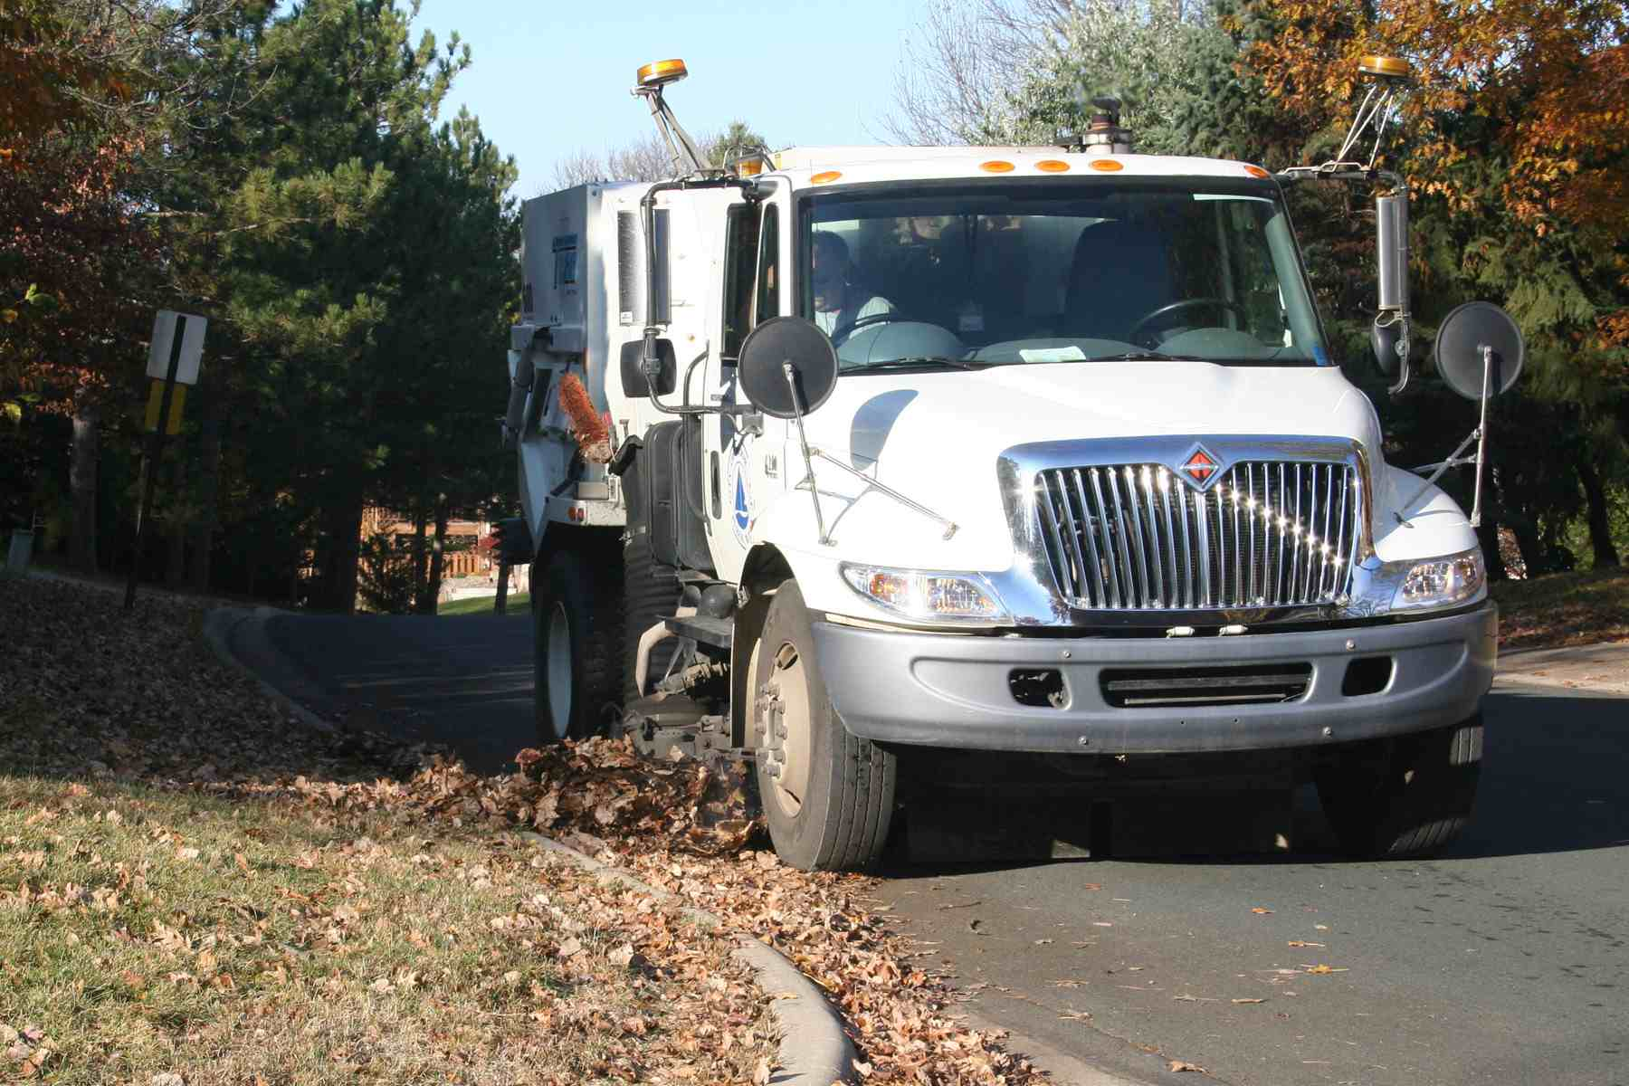
Lawrence A. Baker¹, Sarah Hobbie², Paula Kalinosky^{1,3}
Ross Bintner⁴, and Chris Buyarski²

¹Department of Bioproducts and Biosystems Engineering,
University of Minnesota

²Department of Ecology, Evolution, and Behavior
University of Minnesota

³EOR, Inc.

⁴Engineering Department, City of Edina

Final Report to the EPA 319 Program
MPCA Contract B43119
¹

Introduction

The final report for the Quantifying Nutrient Removal by Street Sweeping project funded through the EPA 319 Program is presented as a short report summarizing the work completed, grant results, and project expenditures. The grant results section describes the project measurements, products developed and presented, public outreach impacts, and long-term results expected from the project. Individual products developed for the project are then attached as appendices.

Section I – Work Plan Review

Task 1: Conduct street sweeping, with field data collection on mass removed and costs. We worked with the City of Prior Lake to develop a protocol for collecting, subsampling, and storing street sweeping samples in the first month of the study, allowing samples to be collected almost immediately. The City of Prior Lake collected 392 sweepings samples over the first two years of the project, compiled GPS records for their sweepers, and conducted a financial breakdown of sweeping costs (labor, fuel, maintenance, capital). These costs were embedded in the Street Sweeping Planning Calculator (Task 2).

Task 2. Conduct literature review, analyze street sweeping samples, analyze data (Tasks 1 and 2), and interpret findings.
We completed a literature review on prior studies of street sweeping in relation to nutrient removal for the User Support Manual. Before analyzing sweeping samples, we developed a unique lab protocol to analyze nutrients in very heterogeneous material, using flotation to separate coarse organic matter (leaves, etc.) from other large particles that did not pass through a 2 mm sieve. The procedure is described in our Users Manual and in the overview journal article. Using this procedure, we analyzed three fractions of each sweeping: fines, coarse organics, and soluble for total P, total dissolved P (soluble only), total N, total C, and dry mass. To interpret the relationship between nutrient and solids removal and tree canopy, we acquired a fine-resolution (0.6 m) land cover database developed for City of Prior Lake by the University of Vermont Remote Sensing Lab, using an expert system approach developed by Dr. Marv Bauer’s research group at the University of Minnesota. This allowed us to determine tree canopy cover with a high degree of accuracy. It also enables users to “map” nutrient removal rates quantified in Prior Lake to any other city with similar land cover mapping.

We analyzed our data to determine the influence of number of sweepings/month, time of sweeping (month of the year), and tree canopy cover. This resulted in three one-equation models to predict (separately) total P, total N, and total solids removed, in kg/curb mile per sweep, and in kg/curb miles per year. This equation was embedded in our Street Sweeping Planning Calculator. We also conducted five-way cross validation statistical analysis to determine the robustness of our model within the City of Prior Lake, and found that it was extremely robust.

Our findings were summarized in a key document “User Support Manual: Quantifying Nutrient Removal by Street Sweeping”. This includes our literature review, a brief summary of findings, including those from the decomposition study (next task), and guidance for using the Street Sweeping Planning Calculator. The Calculator itself is an open-source, Excel-based spreadsheet, now posted at the Stormwater U page (see Products, below).

Task 3. Develop and conduct a leaf litter decomposition experiment.
The goal of this experiment was to determine the potential for short- and long- term release of nutrients from tree leaves falling into streets. To conduct this experiment, we placed autumn leaves of five common species of trees into screen mesh bags, placed them along a curve, and sacrificed them periodically throughout a X month period. Retrieved samples were weighed and analyzed for dry mass, N, P, and C to determine losses. Results were published in the journal Urban Ecosystems (Hobbie et al., see Products) and, in summary form, in our Users Manual.

Task 4. Develop, evaluate, and disseminate a users manual on the topic of street sweeping for stormwater management. We convened a Technical Advisory Group (TAG), mostly stormwater management personnel from cities and MPCA, to advise us on development of the Users Manual. The TAG met every six months. The User Support Manual and accompanying Street Sweeping Planning Calculator were developed to enable professionals involved in stormwater management and/or street sweeping to estimate quantities of solids, N, and P that would be removed under various user-designated scenarios. The TAG was instrumental in providing advice to revise earlier versions of the calculator tool, allowing us to develop a final version that is especially useful as a planning tool, realistic enough to provide reasonable estimates of sweeping load removals, but simple enough to implement that it will be a useful operational tool.

We held four workshops, two with large groups of personnel from public works and street departments of several dozen municipalities, plus a few consultants, attending by a total of 78 individuals. Another workshop was developed for elected officials, part of the NEMO (Nonpoint source Education for Municipal Officials), and a final workshop was developed for MPCA staff, presented across MPCA offices statewide via teleconferencing.

Task 5. Write and submit administrative reports and invoices.
These were written in a timely manner throughout the project.
.

Section II – Grant Results
Measurements:
In the field, wet sweepings loads were measured by weighing the sweeper before and after sweeping using a truck scale. The City of Prior Lake provided odometer readings and GPS-tracked routes to us so that we could compute “curb miles swept” for each of 12 routes swept.
In the lab, core measurements were analyses of 392 sweepings samples, plus appropriate QA samples. Samples were separated into fine solids, coarse organic matter, and water (soluble nutrients) using a novel separation procedure; the solid samples were then ground to powder and analyzed for N, P, and C; water samples were analyzed for soluble N, P, and C.
Street canopy cover was measured using the University of Vermont land cover data set mentioned above. We conducted an extensive analysis of which canopy cover metric best correlated with sweepings load removal, evaluating “over the street” and buffer distances of 5, 10, 20, 50, 100, and 250 feet). In the end, we selected “canopy over the street” as the metric of choice, because it gave good correlations with load removal and was robust.
Products (** = required by work plan):

Several products were developed and presented as a part of the project. The following list of products is grouped by product type. As noted above, the double asterisks identify products required in the project work plan.

Translational tool:
**User Support Manual: Estimating Nutrient Removal by Enhanced Street Sweeping. Kalinosky, P., L. Baker, S. Hobbie, R. Bintner. Report to the MPCA/EPA. Attached as Appendix A.

**Street Sweeping Planning Tool, an Excel spreadsheet, available for free and downloadable from the Stormwater U web site at (http://www.extension.umn.edu/environment/stormwater/pastNov13.html).

Peer-reviewed publications:
** Hobbie, S.E., L.A. Baker, C. Buyarski, D. Nidzgorski, J.C. Finlay. 2013. Decomposition of tree leaf litter on pavement: implications for urban water quality, Urban Ecosystems. DOI 10.1007/s11252-013-0329-9. Attached as Appendix B.

Kalinosky, P., L. Baker, S. Hobbie, R. Bintner. In prep. Quantifying nutrient removal during enhanced street sweeping. Target journal: J. Environmental Engineering. This will also be Paula Kalinosky’s M.S. thesis, to be defended in October 2014. This paper will be included as an appendix when it is accepted for publication.

Magazine and web-based articles:
Baker, L., P. Kalinosky, S. Hobbie, R. Bintner, and C. Buyarski. Quantifying nutrient removal by enhanced street sweeping, Stormwater Magazine, Feb/March 2014. http://www.stormh2o.com/SW/Articles/Quantifying_Nutrient_Removal_by_Enhancd_Street_Sw_24833.aspx.

Kalinosky, P., L. Baker, S. Hobbie, R. Bintner. March 2013. Quantifying Nutrient Removal through Targeted Intensive Street Sweeping. Stormwater Updates, http://stormwater.safl.umn.edu/updates-march-2013.

Workshops:
**Quantifying Nutrient Load Recovery through Targeted, Intensive Street Sweeping . Kalinosky, P., L. Baker, S. Hobbie, C. Buyarski, R. Bintner. Stormwater U Workshops, Materials posted at Stormwater U, http://www.extension.umn.edu/environment/stormwater/pastNov13.html
Dates:
Workshop #1: Nov. 12, 2013
Workshop #2: Nov. 27, 2013
Workshop #3 (Presented by J. Biloti on April 26, 2014)
Workshop #4: Are trees an important source of nutrients to streets? The Prior Lake Street Sweeping Experiment. Videoconference at the Minnesota Pollution Control Agency, April 10, 2014. Slideshow attached as Appendix C.

Other Presentations primarily about the street sweeping study:
- Baker, L. Removal of nutrients by street sweeping. Minnehaha Creek Watershed District Board Meeting, March 27, 2014. (attendance ~ 20).
- Baker, L. Quantifying Nutrient Load Recovery through Targeted, Intensive Street Sweeping Washington County Water Consortium, Nov. 6, 2013. (attendance ~ 30).
- Kalinosky, P. Quantifying Nutrient Load Recovery through Targeted, Intensive Street Sweeping, presented via a Chesapeake Stormwater Network Videoconference, October 29, 2013.
- Kalinosky, P. Quantification of nutrient removal by street sweeping: the Prior Lake Street Sweeping Project. International Low Impact Development (LID) Symposium, St. Paul, MN, August 8-13, 2013. Posted at https://www.linkedin.com/profile/edit?trk=nav_responsive_sub_nav_edit_profile. (attendance ~ 40).
- Baker, L. Moving Enhanced Street Sweeping from Prior Lake to St. Paul (presentation and discussion), St. Paul Public Works, June 4, 2013. (attendance =15)
- Kalinoski, K. Quantifying nutrient load reductions through targeted, intensive street sweeping - a field study by the University of Minnesota in partnership with the City of Prior Lake, Minnesota Water Resources Conference, October 16-17, 2012. Slideshow posted at http://larrybakerlab.cfans.umn.edu/research-projects/quantifying-nutrient-removal-by-street-sweeping/. (Attendance ~ 80)

Presentations based partially based on the street sweeping project:
- Baker, L., S. Hobbie, J. Finlay, P. Kalinosky, and B. Janke. Moving upstream to reduce urban stormwater phosphorus loading (invited), Session on Water, Energy and Society in Urban Systems, organized by D. Jenerette, J. Loperfido, A. Watts and C. Welty, Dec. 9, 2013 AGU meeting, San Francisco. (attendance ~ 40)
- Baker, L. Rethinking nutrient management in cities (invited). International Low Impact Development (LID) Symposium, St. Paul, MN, August 18-21, 2013. (attendance ~ 40).
- Baker, L. The water environment of urban ecosystems: from theory to the street (invited). Minnesota Association of Landscape Architects Annual Education Conference, St. Paul, April 20, 2012. (attendance ~ 100)
- Flowpaths of nutrients through urban ecosystems. Presented at a TMDL stakeholders meeting, Minnesota Pollution Control Agency, May 3, 2012. (attendance ~ 25).
- Baker, L., S. Hobbie, D. Nidgorski, C. Fissore, S. Panzer, J. King, J. McFadden, K. Nelson. Movement of P through urban ecosystems. Am. Society of Limnology and Oceanography, San Juan Puerto Rico, Feb. 2011. (attendance ~ 50).

Guest lectures with some inclusion of project results (12 total):
- Ecology, Evolution, and Behavior (EEB 3603 Science, Protection and Management of Aquatic Ecosystems) – “Managing nutrients in urban ecosystems: moving toward the metabolic city”, Spring 2013 and 2014.
- School of Design (Contemporary Sustainable Neighborhoods: Issues and Directions) – “The water environment of cities”, Spring 2013 and 2014.
- Environmental Studies Program (Cities, Sustainability, and Campus)- “Cities as Urban Ecosystems”, Sept. 2011 (Macalester College).
- Architecture (Ecology and Architecture)- “Planning for the urban water environment”, March 2011, 2014.
- Architecture (Sustainable Landscape Design) – “Biogeochemial perspectives on stormwater management”, 2008, 2009, 2010, 2011, 2013.

Photos:
The photo on the title page is attached as a JPG in Appendix D.

Public outreach and education (audiences):
Public outreach and education occurred through the development and presentation of the project products listed above. A brief description of the audiences reached by product type is given below.
Magazine and web-based articles. Our article in Stormwater Magazine potentially reached 25,000 subscribers. The article posted on the Stormwater Updates webpage potentially reached 3,000 subscribers.
Academic journals. We anticipate that several hundred people each will read two articles produced by this project, and cited 20-100 times each, over time.
Workshops. Approximately 80 people attended each of the first two workshops. These were mostly professional public works staff and consultants. Post-workshop evaluation revealed that 93% responded that they found the planning calculator tool “helpful” or “very helpful”; 96% “strongly agreed” or “somewhat agreed” that our workshops provided them with “new skills to plan street sweeping for nutrient removal; and 86% responded that their cities would “very likely” or “somewhat likely to adopt enhanced street sweeping over the next 3-5 years. More evaluation details are presented in Appendix E.
Other talks. We estimate that about 440 people attended other talks. Audiences were highly varied. Some audiences comprised mainly watershed managers and planners; others were mostly research scientists.
Guest lectures. Classes were mostly upper division classes, which typically have about 20 students, on average, so we estimate that about 220 students attended 12 lectures across diverse disciplines.
In summary, it is very likely that our message has reached most of the public works or streets departments in cities in the Twin Cities region, as well as many watershed/water quality professionals in the region. The project has also acquired national visibility.

Long-term results:
This project has accomplished several things. First, it has quantified, for the first time, inputs of nutrients (nitrogen and phosphorus) and solids to streets in relation to overlying tree canopy cover throughout the entire snow-free part of the year. Second, it has shown the street sweeping can be economically efficient, in terms of $/lb P removed, with costs sometimes < 100/lb P for high canopy streets in the spring and fall, a far lower cost than for most structural BMPs. Third, we developed a user-friendly Street Sweeping Planner Calculator that enables public works and streets department staff to estimate quantities of nitrogen, phosphorus, and solids would be removed for each user-define sweeping route, with user-specified sweeping frequency and timing (by month). The calculator also calculates fuel, labor, and equipment costs for each scenario. This allows public works and streets departments to optimize planning scenarios, which they can present to their city councils with confidence, and allows city councils to make informed decisions regarding any additional expenses needed. The Planning Calculator therefore lowers the threshold for adoption.

The graduate student who worked on this project for her M.S. thesis, Paula Kalinosky, is now working at EOR, a local environmental consulting firm, where she has started several new projects to plan enhanced sweeping scenarios for the Browns Creek Watershed District (for areas in the city of Stillwater) and for the City of Edina. She has noted that enhanced street sweeping may be a recommended BMP in some watershed analyses that EOR is doing for the City of Crosby, Minnesota; the City of Thunder Bay, ON; and others. Two years ago, she worked on a graduate student project team with Minnehaha Creek Watershed District on a surface water quality improvement project that included enhanced sweeping.

With regard to the University’s long-term effort regarding street trees and street sweeping, we (co-PIs Baker and Hobbie, along with others) are developing a conceptual model of flowpaths of nutrients in urban landscapes. Data from our sweeping study has informed this model, which we hope leads to better understanding of how to reduce nutrient inputs to storm drains. For example, we have found a strong correlation between tree canopy cover in six subwatersheds of the Capital Region Watershed District and modeled coarse organic P (COP) removal by sweeping.

As to “lessons learned”, this has been one of the most rapidly translated projects that either the PI or co-PI has worked on, and an experience that we hope to repeat. This occurred for two reasons: (1) our research filled a void in knowledge that, once filled, had enormous practical application; and (2) we developed an accessible modeling tool that is simple enough to use that it is leading to rapid adoption by cities.

With regard to MPCA, we greatly appreciated Greg Johnson’s (our project officer) effort to enable us to present our findings of two 319 projects to MPCA offices statewide, and have suggested that MPCA might in the future hold “319 workshops” for projects to share findings.

Section III – Final Expenditures

The final budget spreadsheet, showing expenses by task, is attached as Appendix F.

Appendices

Appendix A. User Support Manual: Estimating Nutrient Removal by Enhanced Street Sweeping. Kalinosky, P., L. Baker, S. Hobbie, R. Bintner. Report to the MPCA/EPA

Appendix B. Hobbie, S.E., L.A. Baker, C. Buyarski, D. Nidzgorski, J.C. Finlay. 2013. Decomposition of tree leaf litter on pavement: implications for urban water quality, Urban Ecosystems. DOI 10.1007/s11252-013-0329-9.

Appendix C. Workshop #4: Are trees an important source of nutrients to streets? The Prior Lake Street Sweeping Experiment. Videoconference at the Minnesota Pollution Control Agency, April 10, 2014.

Appendix D. Photo of street sweeping.

Appendix E. Workshop evaluations.

Appendix F. Budget and final expenditures.

