**User Support Manual:**

**Estimating Nutrient Removal by Enhanced Street Sweeping**

Paula Kalinosky1,3, Lawrence A. Baker1, Sarah E. Hobbie2,

Ross Bintner4,5, and Chris Buyarski2

1Department of Bioproducts and Biosystems Engineering

University of Minnesota

2 Department of Ecology, Evolution, and Behavior

University of Minnesota

3Current address: EOR, Inc.

4City of Prior Lake, Minnesota (during project period)

5Current address: City of Edina, Minnesota

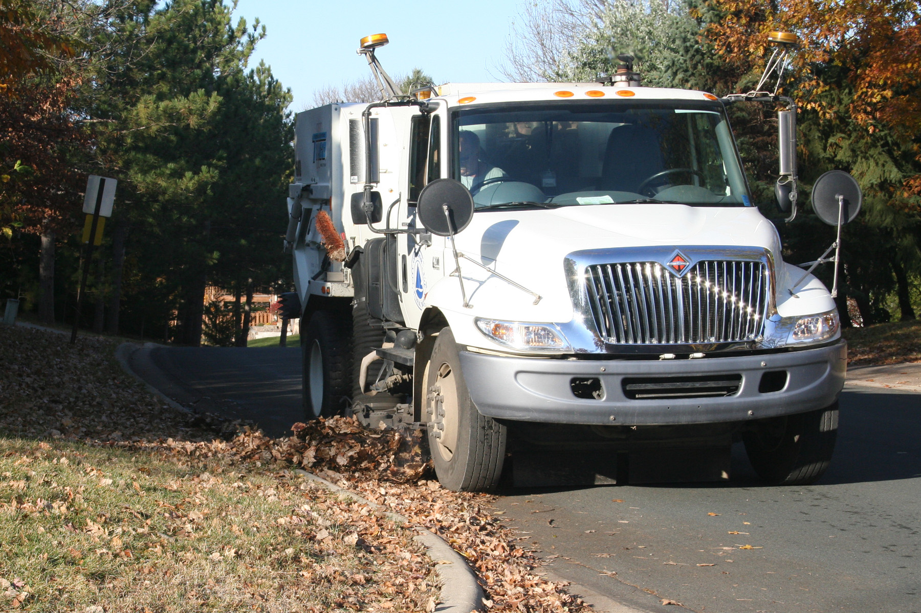

**Project Support:**

**Minnesota Pollution Control Agency**

**and the U.S. EPA**

Contents

Chapter 1. Introduction 1

Chapter 2. Literature Review 5

Early Street Sweeping Studies and NURP 5

Street Sweeper Performance and Efficiency Studies 6

Continued Work on Street Sediment Characterization 7

Modeling Studies and Renewed Interest in Street Sweeping as a Water Quality Management Tool 8

End of Pipe Studies – Promise and Pitfalls 9

Focus on Source Control and Maintenance Practices 10

Street Sweeping and Nutrient Management 12

Summary 13

Chapter 3. The Prior Lake Street Sweeping Experiment 14

Study Area 14

Study Design 14

Tree Canopy Cover 15

Street Sweeping Routes 15

Field Methods 16

Field Operations Data Collection 16

Sweeping Protocols 16

Sample Collection Procedures 17

Disposal of and Reuse of Sweeper Waste 17

Laboratory Methods 18

Chemical Analysis 19

Data Analysis Methods 20

Tree Canopy Cover Analysis Methods 20

Route Curb-Mile Analysis 20

Statistical Analysis Methods 21

Summary of Findings 21

Tree Canopy Cover Analysis 21

Where to Sweep (The Influence of Tree Canopy of Recovered Loads) 22

How Often to Sweep (The Combined Influence of Tree Canopy Cover and Sweeping Frequency on Recovered Loads) 23

When to Sweep (The Influence of Season on Recovered Loads) 26

Cost of Nutrient and Solids Recovery 36

Key Findings and Limitations of the Study 39

Key Findings 39

Limitations 39

Chapter 4. DECOMPOSITION AND LITTER LEACHING TEXT 41

Goals 41

Methods 41

Leaf Litter Decomposition 41

Leaf Litter Leaching 42

Results 43

Decomposition 43

Chapter 5. Planning Calculator Tool for Estimating Nutrient and Solids Load Recovery through Street Sweeping 50

General Model for Predicting Solids and Nutrient Loads 50

User Guide to the Planning Calculator Tool 52

LITERATURE CITED 56

QUALITY ASSURANCE/QUALTIY CONTROL 61

Appendix A 64

Appendix B 65

Appendix C 66

Appendix D 67

Appendix E 68

Appendix F 69

Appendix G 70

Appendix H 71

Appendix I 72

Appendix J 74

Tables

Table 1. Comparison of Sweeping Fractions Recovered by Canopy Cover Category, Two-year Study Averages and Totals. 23

Table 2. Total dry solids (annual average) collected by route (lb/curb-mile/year) 24

Table 3. Average dry solids collected per sweep by route, (lb/curb-mile) 24

Table 4. Average coarse organic and fine sediment loads (dry weight) recovered per sweep by route, (lb/curb-mile) 24

Table 5. Regressions for predicting average phosphorus recovered per sweep based on overhead tree canopy and sweeping frequency 26

Table 6. Average cost of phosphorus recovery in $/lb during months when sweeping was most cost effective. 39

Table 7. Initial litter chemistry for five species studied. All parameters are expressed in percent of total mass. Values are means (standard errors). 45

Table 8. Results of five-fold cross-validation for 51

Table 9. Swept Miles Audit Results 74

Figures

Figure 1. Air photos showing examples of low, medium, and high canopy zones. 19

Figure 2. Overview of procedure for separating fine, coarse organic and soluble fractions. 23

Figure 3. Tree canopy cover at various buffer distances from the curb for study routes. 26

Figure 4. Average phosphorus recovered per sweep vs. tree canopy cover by sweeping frequency. 29

Figure 5. Average nitrogen recovered per sweep vs. tree canopy cover by sweeping frequency. 29

Figure 6. Total dry solids collected by month and year, all routes. 31

Figure 7. Total fine sediment recovered by month and year, all routes. 32

Figure 8. Total coarse organics recovered by month and year, all routes. 32

Figure 9. Total phosphorus (lb) recovered by month and year, all routes. 34

Figure 10. Phosphorus recovered (lb/curb-mile), by month and year, all routes. 34

Figure 11. Phosphorus recovered in the coarse organic fraction by month and year, all routes. 35

Figure 12. Phosphorus recovered in the fine fraction by month and year, all routes. 35

Figure 14. Total nitrogen recovered by month and year, all routes. 36

Figure 15. Nitrogen recovered by month and year, all routes. 36

Figure 16. Nitrogen recovered in the coarse organic fraction month and year, all routes. 37

Figure 17. Nitrogen recovered in the fine fraction by month and year, all routes. 37

Figure 18. Average mass percent of recovered dry solid, phosphorus and nitrogen loads recovered as coarse organics by month, all study routes. 38

Figure 19. Phosphorus concentration in the fine fraction by month (all routes). 39

Figure 20. Percent organic content in the fine fraction by month (all routes). 39

Figure 21. Costs for sweeping in $/mile (all routes) by month. 41

Figure 22. Monthly average cost of phosphorus recovery in $/lb for routes with the highest (L4) and lowest (H2) overall mean cost per pound. 42

Figure 23. Installation of litterbags along a curb. 46

Figure 24. Decomposition of litter of five tree species decomposing in a street gutter, expressed as the proportion of the initial ash-free dry mass remaining over time. 48

Figure 25. Nitrogen dynamics of litter of five tree species decomposing in a street gutter, expressed as the proportion of the initial nitrogen content present over time. 50

Figure 26. Phosphorus dynamics of litter of five tree species decomposing in a street gutter, expressed as the proportion of the initial phosphorus content present over time.. 51

Figure 27. The proportions of the initial pools of nitrogen (top) and phosphorus (bottom) leached from litter over 0.5 and 24 hours in a laboratory experiment. 52

Figure 28. The total amount of dissolved nitrogen (top) and phosphorus (bottom) leached from litter over 0.5 and 24 hours in a laboratory experiment. 53

# Introduction

Nearly every city in Minnesota uses street sweeping to improve the appearance of streets, make them safe for bicyclists and walkers, and reduce the quantity of material entering storm drains. In a survey of street sweeping operations in Minnesota’s cities, (Schilling 2005) reported that 57% of respondents swept more than one a year. The most common frequency for most types of roads was twice per year, but “sediment accumulation areas” were most commonly swept 3-6 times per year. Central business districts were swept most often: 27% were swept once a week or more often. In the same survey, 62% of respondents reported that they would sweep more often if it resulted in water quality benefits (and if funding were available). Whether street sweeping benefits water quality has been a recurring question since the inception of EPA’s Stormwater Program in 2000, which places stormwater conveyances under the same general regulatory program (the National Pollution Discharge Elimination Program) that formerly include discharges from sewage treatment plants, with the moniker “Municipal Separate Storm Water System”, known as the MS4 program.

As the MS4 program evolves, it is moving from operational mandates with no specific water quality goals to mandates based on water quality goals that are specific to the receiving water body. Ten years ago, a MS4 permit might have specified that certain best management practices (such as stormwater ponds) be used. In the near future, permits will specify allowable pollutant discharge limits much the way that limits apply to lakes and rivers that are designated as legally “impaired”. This regulatory process has resulted in an increased interest in street sweeping. While it is generally felt that street sweeping must help reduce the quantities of nutrients being flushed from streets to lakes, there has not been a good way to quantify this effect.

For urban lakes, the most common type of impairment occurs because of an overload of nutrients, mainly phosphorus. Excessive phosphorus (and nitrogen) increases the algal abundance in a lake, reduces clarity, shifts the dominance of algae from green to blue-green types, and can result in anoxic conditions (absence or near absence of oxygen) at the bottom of the lake. This process, called eutrophication, also reduces the recreational value of a lake and reduces the value of lakeshore property (Baker and Newman 2014). Reducing the input of P to a lake reduces algal abundance, increases clarity, and generally reverses the process of eutrophication.

We conducted a unique experiment, the Prior Lake Street Sweeping Project, to address the question: what quantities of nutrients could be removed from streets by street sweeping under various conditions? This project provides new types of information that can be used to help cities upgrade their street sweeping operations to meet water quality objectives. First, we addressed this issue in a novel way: rather than try to measure changes in stormwater loading with various sweeping routines, which is very difficult to do (and hence yields conflicting results; see Chapter 3), we developed a protocol for measuring solids and nutrients (nitrogen and phosphorus) *removed by the sweeper*. The very reasonable premise is that material removed from streets by sweepers does not enter stormwater conveyances: a pound of phosphorus removed by the sweeper is one pound less that enters the stormwater conveyance! Hence, city-engineering departments can compute the “load reduction” accomplished by street sweeping over a year. This makes it possible to incorporate street sweeping directly into TMDL “load reduction” programs intended to restore nutrient impaired waters.

Second, the Prior Lake study was a factorial experiment, in which we swept streets under varying tree canopy levels (low, medium, and high) and with different frequency (1x/month, 2x/month), and 4 times/month). In other words, some streets with low tree canopy cover were swept once a month, others twice, and yet others four times per month. The same was done with medium and high canopy streets. Hence, results can be “mapped” onto the streets of other similar cities to estimate nutrient and sediment load reductions expected under various tree canopy levels and sweeping frequencies.

Third, we started sweeping very early in the spring (as soon as the snow melted) and continued throughout the autumn leaf fall period – until the snows started. This is one of very few studies that have continued sweeping throughout the fall. This is important because our findings show that an important fraction of the annual loads of nutrients and sediments enters streets during autumn leaf fall.

Last, but certainly not least, we tabulated costs, including labor, fuel, and operations and maintenance of the sweepers. We could therefore compute the cost per pound for removal of nutrients and solids for each experimental treatment. This information would allow potential adopters to estimate costs of enhanced sweeping practices under various conditions (tree canopy and frequency).

The Prior Lake Street Sweeping Experiment was a collaborative experiment between the City of Prior Lake and the University of Minnesota, with financial support from the Minnesota Pollution Control Association via the U.S. Environmental Protection Agency’s Nonpoint Source (319) Program.

**How you might use this manual**

This User Support Manual is intended to support municipalities that would like to improve the effectiveness and efficiency of street sweeping as a stormwater management practice to reduce the input of nutrients and solids to stormwater catch basins. The User Support Manual was designed to support an Excel spreadsheet program **Street Sweeping Planning Calculator**: **Estimating Nutrient And Solids Load Recovery through Street Sweeping**, providing step-by-step instructions. This manual and spreadsheet can be used in several ways.

(1) Planning new sweeping operations. First, the manual and the accompanying spreadsheet can be used to estimate quantities of nutrients and solids removed in planning more intensive sweeping operations. For example, one could estimate, for a given level of tree canopy cover, the increase in quantities of nutrients and solids that would be removed by moving from once a year sweeping to monthly sweeping, for a given level of canopy cover.

(2) Quantifying actual load reductions from sweeping. The manual also steps you through the process of quantifying the load reductions for your current operations. In Chapter X, we outline a process for collecting swept material, drying and weighing it, and estimating the nutrient content at [several levels of effort and accuracy]. This process would allow you to compute the annual load of nutrients and solids actually removed during your ongoing operations.

(3) Estimating impacts on lakes. Many urban lakes in Minnesota are impaired for nutrients. This is a legal definition that triggers the development of TMDL (total maximum daily load) plans. TMDL plans include estimates of the current P loading to the lake, and the P load reduction that would be required to attain the legally mandated level of algal abundance (and clarity), stated as a percentage of the current P load, and as a load reduction (kg P per year). Cities could then use this Users’ Manual to estimate the P load reduction that could be accomplished using various sweeping scenarios – that is, compute how much P is recovered through sweeping and therefore prevented from entering the stormsewer system...

(4) Increasing cost efficiency. One of the most important uses of this manual is that you could use it to estimate the cost of each sweeping scenario – $ per pound of P removed, and total cost of each scenario for an entire watershed or city. Combined with (3), one could estimate the cost of achieving various lake nutrient goals for a lake’s watershed.

(5) Landscape planning. Finally, the manual could provide planners and landscape architects with a tool they could use estimate leaf inputs to streets for various types of tree plantings.

**Audience**

The primary audiences for this manual are the municipal public works, engineering, or streets departments that manage street sweeping operations and/or stormwater programs, along with water resource managers in the urban watershed districts with whom cities collaborate. The manual might also be useful to planners and landscape architects who design the intersection between streets and vegetated landscapes, and who might want to incorporate estimates of tree leaf inputs to streets in their design considerations. It might also be useful to urban foresters, who manage trees in public spaces, including boulevard plantings, for the same reason.

**What is in this manual?**

Chapter 2 is a summary of prior research on the effects of street sweeping as a method for reducing nutrient and solids loadings to stormwater. This chapter provides context for the Prior Lake experiment.

Chapter 3 is a summary of the Prior Lake Street Sweeping Experiment. This chapter provides details of the experimental design, the field (sweeping) measurements, the lab analysis, and the interpretation of findings.

Chapter 4 describes a Leaf Litter Decomposition Experiment, designed to quantify the rate of nutrient leaching from leaves left in the gutter. Findings from this experiment were used to estimate the quantities of nutrients that would be leached to stormwater over various time periods, from one day to twelve months.

This information can help street sweeping managers determine how quickly they need to sweep leaves before nutrients are “lost” to stormwater conveyances.

Chapter 5 documents the Street Sweeping Calculator, an Excel spreadsheet intended to allow users to compute nutrient loadings being achieved in their street sweeping programs and to estimate nutrient load reductions that might be achieved with more extensive sweeping programs.

**Acknowledgements**

This project was funded by Contract Number B43119 from the Minnesota Pollution Control Association, using funds from the Environmental Protection Agency’s Nonpoint Source (“319”) Program. We would like to thank the two individuals from the City of Prior Lake for their roles in this project: Brad Hansen (retired), street sweeping supervisor; Steve Albrecht, formerly Director of Public Works. We would also like to acknowledge the undergraduate lab techs who analyzed the sweepings in the Hobbie lab: Claire Baglien, John Brockgreitens, Ayeza Jamil, Cathleen Nguyen, Grace Park, Madhvi Patel, and Jennifer Pederson. We would also like to thank Dr. Marv Bauer for sharing the fine-scale land cover mapping developed by his research group. Finally, we thank our external Technical Advisory group: Lois Eberhart (City of Minneapolis), Anne Gelbmann (Minnesota Pollution Control Agency), Randy Neprash (Bonestro, Inc.), Wes Saunders-Pierce (City of St. Paul), Joel Schilling (independent consultant), Mike Trojan (Minnesota Pollution Control Agency); and our MPCA Project Officer, Greg Johnson.

# Literature Review

Prior to the 1970’s, the main goal of stormwater management was to drain urban watersheds quickly. Early sewer systems in US cities were most often built as combined systems, which carried sewage and surface runoff to a receiving surface water body with little or no treatment (Tarr 1996). As populations grew, increasing amounts of treatment were added to these systems to insure sanitary conditions in public drinking water supplies located downstream of the outfalls of these sewers. The cost of this additional treatment drove a movement to separate municipal and storm sewers (Burian et al. 1999). Ironically, diversion of stormwater from treatment with sanitary waste may have unmasked the pollution loads present in urban stormwater. The US Public Health Department became concerned about pollutants identified in urban runoff in the 1960s, but the original 1972 Clean Water Act focused mainly on point sources of pollution (such as municipal and industrial wastewater discharges).

Pioneering research into storm sewage, including using street sweeping as a pollution control measure, was completed during this era (Heaney and Sullivan 1971, Sartor and Boyd 1972, Pitt and Amy 1973, Shapiro and Hans-Olaf 1974). Initial conclusions regarding the value of street sweeping as a water quality tool were not always positive, but amendments to the Clean Water Act in 1987 and development of the EPA’s Stormwater Program have prompted a re-evaluation of these conclusions and a renewed interest in street sweeping as a pollution control measure.

## Early Street Sweeping Studies and NURP

Early street sweeping studies were concerned largely with characterizing street sediments and evaluating the performance of street sweepers. An extensive study by Sartor and Boyd (1972) characterized the accumulation and composition of street sediments in 12 urban centers around the country and found street sediments were composed largely of inorganic material such as sand and silt, 78% of which could be found within 6 inches of the curb. The fine fraction (< 43 µm) of these sediments contained a great portion of the overall pollution load. While this fraction was typically small, about 6% of the total solids, it contained one-fourth the total chemical oxygen demand (COD), one-third to one-half of the nutrients, and significant percentages of various heavy metals. Although sweepers were generally very effective at removing larger debris and sediments from roads (79% effective overall), removal efficiencies for the finest fractions were only 15-20%. The combined findings indicated that street sweeping, which removed less than 50% of the total sediment load on the street, would be relatively ineffective as a water quality management tool.

Sartor and Boyd did not monitor stormwater quality in their study, but the need to link source control practices to stormwater quality improvements would become the proving ground for street sweeping during the EPA-sponsored National Urban Runoff Program (NURP), conducted from 1979 to 1983. The NURP program provided technical support and management assistance for 28 projects across the United States, which investigated urban hydrology and water quality. Among these studies, street sweeping was evaluated at 17 sites in 5 cities across the United States. To show definitively the effectiveness of street sweeping in reducing stormwater pollutant loads, all NURP studies used a paired or serial basin approach in which swept (treatment) and unswept (control) basins or treatment phases were compared. The criteria for a positive result were documented reduction of 50% stormwater event mean concentrations (EMCs, EMC = flow-weighted mean concentration throughout a runoff event), with 90% statistical confidence.The final NURP report was not promising for street sweeping. Sweeping never caused a 50% load reduction with 95% confidence (EPA’s criterion) for any of the five major pollutants monitored [lead (Pb), total Kjeldahl nitrogen (TKN), total phosphorus (TP), chemical oxygen demand (COD), and total suspended solids (TSS)], at any of the 17 study sites (EPA 1983).

The final recommendation was that street sweeping was generally ineffective as a water quality improvement tool. The lackluster conclusions of NURP appear to have derailed interest in street sweeping as a BMP for about the next decade. Literature on street sweeping from 1985-1995 is sparse. The intuitive appeal of street sweeping as a source reduction tool was, however, hard to ignore. The development of higher efficiency sweepers, better stormwater modeling software, and critical analysis of NURP methods would all contribute to a renewed interest in street sweeping as the enactment of NPDES permitting (1990, 2003) increased regulation on stormwater quality.

## Street Sweeper Performance and Efficiency Studies

Street sweeper testing methods and data collected on sweeper efficiency by Sartor and Boyd provided a foundation for future sweeper performance testing (Burton and Pitt 2002). A variety of parameters influence street sweeper efficiency: the mass, particle size distribution and uniformity of the sediment load; the type and condition of pavement; pick-up broom type, diameter, angle and rotational speed; and the influence of other operational parameters including forward speed and number of passes. Sweeper pick-up performance and efficiency testing is a sub-class of street sweeping study which, although important to best practices, is not a focus in the current study. Sweeper studies have rated sweeper pick-up performance by total solids removed and percent removal by particle size classes, for various loading conditions, and under various operational parameters (Sutherland and Jelen 1997, Breault et al. 2005, Selbig and Bannerman 2007). Work in this area has addressed potential standardization of testing protocols for sweeper performance evaluation (Sutherland 2008) and development of resources for guiding street sweeper purchasing and program implementation (CT DEEP 2007, Kuehl et al. 2008, others). Evaluations largely agree that because regenerative air and vacuum type sweepers remove fine particles with greater efficiency than mechanical sweepers, these types are preferred when sweeping for water quality. Mechanical broom sweepers are preferred for removal of large debris and highly compacted material. High- efficiency sweepers combine various sweeper technologies with dust control systems and improve sweeper efficiency in removal of fine particles, but tend to cost considerably more than other sweeper types (Sutherland 2011).

## Continued Work on Street Sediment Characterization

Data on street sediment characterization are used in stormwater modeling, sweeper efficiency modeling, and for determining the proper use and disposal of street sweepings. Chemical analysis of street sediments, most often analysis of metals and organic contaminants, has been performed in numerous studies (Pitt and Amy 1973, Wilber and Hunter 1979, Townsend et al. 2002, Zarriello et al. 2002, others). Fine sediments have frequently been found to contain a significant proportion of metal pollutant loads (Pitt and Amy 1973, Durand et al. 2003, Deletic and Orr 2005, Rochfort et al. 2009). Fewer studies have looked at the relationship between particle size and nutrient concentrations in street sediments and results are quite variable. The percent mass of phosphorus has been variously reported as highest in fine sediments (< 104 µm)(Sartor and Boyd 1972), silt and clay sized particles (Breault et al. 2005), and larger particles > 250 µm (Waschbusch et al. 1999).

Street sediment composition has been shown be to be influenced by season (Deletic and Orr 2005), land use area (Seattle Public Utilities 2009, Berretta et al. 2011), and street type ([X]-Absolute Value 1996). The distribution of sediments across the street can be affected by winter road applications and spring snow melt (Selbig and Bannerman 2007). Particle size distribution and pollutant concentration of sediment samples can be influenced by distance from the curb (Deletic and Orr 2005).

Although exceptions occur on a regional basis or for particular pollutants, concentrations of metals and organic pollutants in street sweepings have generally been found to be below soil contamination standards (Townsend et al. 2002, Durand et al. 2003, [X]-Absolute Value 1996, Land Technologies 1997). A sampling of best management practices for street sweepings indicates that screened sweeping material does not typically qualify as hazardous waste (CT DEEP 2007, Minnesota Pollution Control Agency (MPCA) 2010). Appropriate uses for street sweepings include construction fill, landfill cover, winter non-skid material, aggregate in asphalt and concrete, and compost (vegetative fraction) (Land Technologies 1997, Minnesota Pollution Control Agency 2010, Clark et al. 2007, MWH Americas 2002).

## Modeling Studies and Renewed Interest in Street Sweeping as a Water Quality Management Tool

Early street sweeping studies established mathematic models describing accumulation, wash-off, transport, and removal of street sediments, which were used to model theoretical stormwater load reductions from street sweeping. Due to the low efficiency of mechanical broom sweepers, particularly in the smaller particle size ranges, NURP-era models showed that streets must be swept at a frequency about equal to or greater than the inter-event dry period to have any effect on reducing the total solids load on the streets (Sartor and Gaboury 1984). The post-NURP decade brought new higher efficiency sweepers and improved stormwater modeling software into the market. These technological improvements prompted a number of papers that re-evaluated the value of street sweeping as a water quality management tool (Sutherland and Jelen 1997, Sutherland and Jelen 1996, Sutherland et al. 1998, Minton et al. 1998).

Among these modeling studies, (Sutherland and Jelen 1997) used the Simplified Particle Transport Model (SIMPTM) to compare the total suspended solids (TSS) removal capacities of the newer, high efficiency sweeping technologies with older sweepers. SIMPTM allowed the modeler to set base residual loads and sweeper removal efficiencies for different particle sizes and sweeper types. SIMPTM also had the capacity to continously model accumulation, washoff, and resuspension of particles and associated pollutants on an event-by-event basis. In this study, the model predicted TSS reductions of up to 20-30% for newer mechanical sweepers and up to 80% for the Envirowhirl™ technology. SIMPTM was also used to model targeted total solids reduction in Jackson County, MI (Tetra Tech 2001). Modeled load reductions for TS, COD, TP, Cd, Cr, Pb, Cu, and Zn ranged from 63 -87% for high efficiency sweepers and 49 – 85% for regenerative air sweepers for a sweeping frequency of once to twice monthly with cleaned catch basins.

Modeling using the Storm Water Management Model (SWMM) in the Lower Charles River basin produced less promising pollutant load reductions from sweeping (Zarriello et al. 2002). A conservative assumption that 20% of the surface was unavailable to be swept (parked cars, other) was built into the model. Simulations predicted load reductions of less than 10 percent for total solids and less than 5% for fecal coliform and total phosphorus for a sweeping frequency of seven days or greater. These estimates improved when a lower value of the wash-off coefficient was used to model sediment removal during smaller storms, which resulted in larger residual loads being available for removal through sweeping. The discrepancy highlights the sensitivity of predictions to modeling assumptions and constraints. Improved stormwater quality modeling has been an active areas of research that includes empircal validation of modeling parameters (Breault et al. 2005), accumulation rates (Kim et al. 2006), and optimization of street sweeping practices for water quality improvement (Sutherland 2007b).

## End of Pipe Studies – Promise and Pitfalls

Although modeling studies have shown various degrees of promise for sweeping as a water quality BMP, *measured* reductions in pollutant EMCs or loadings have continued to be the standard by which sweeping is gauged. An extensive study, which had both paired and serial basin aspects, was conducted in Madison, WI, from 2003-2007 (Selbig and Bannerman 2007). Street sediment yield and storm EMCs for 26 constituents were monitored during calibration and treatment (sweeping) phases in three residential basins. A fourth basin served as a control for all three swept basin comparisons. Sweeping was conducted from April through September during each year of the study, and was suspended when autumn leaf accumulations made vacuum sampling impractical. For a frequency of once per week, sweeping reduced street sediment yield by an average of 76%, 63%, and 20% respectively for regenerative air, vacuum assist, and high-frequency mechanical broom treatments but data on stormwater quality improvement was less encouraging.

Approximately 40 paired water quality samples were collected during the Madison study. Based on this sampling, the only significant change in stormwater concentrations was an increase in ammonia-nitrogen of 63% in one of the treatment basins (10% significance). Study authors reported that high variability in stormwater composition (as is typical in stormwater monitoring) made statistical comparisons of calibration and treatment phases difficult. Sources of variability in stormwater composition include differences in precipitation patterns, land use, street type, traffice patterns, maintenance practices, and sediment sources other than street dirt (ex. rooftops, lawns, driveways, and sediments transported in the sewer system), which are not controlled through street sweeping. Variability in stormwater loads dictates large sampling requirements to produce statistically relevant results at high levels of confidence. In the Madison study, for a coefficient of variation of 1.5 between control and test basins, a minimum of 200 paired samples would have been required to detect a 25% difference (at 95% confidence, 0.5 power) between calibration and treatment phase stormwater EMCs (Selbig and Bannerman 2007). For most constiuents, the sampling completed was not sufficient to demonstrate a significant change. More recent studies have abandoned attempts to quantify stormwater quality improvements associated with street sweeping due to insufficient sampling (Law et al. 2008) or because sufficient sampling was cost-prohibitive (Seattle Public Utilities 2009).

Given the difficulties in proving reductions in EMCs or loading at the end of the pipe, it is not surprising that contemporary studies have questioned the value of NURP criteria and conclusions (Minton et al. 1998, Sutherland 2007b, Kang et al. 2009). Critical review of data analysis methods has shown that many NURP-era studies lacked the statistical power required to draw statistically significant conclusions about water quality, making inferences about the influence of street sweeping on water quality only speculative(Kang et al. 2009). Others have argued that NURP criteria were unrealistic. Because EMC reduction of 50% or greater would be difficult to demonstrate at high confidence levels, results should be re-evaluated (Minton et al. 1998). Although there were no instances in which stormwater EMC reductions met the EPA criteria for a postive result, for the five pollutants studied, NURP data showed EMC reductions in 30 of 50 cases evaluated (range approximately 5%-55%). While EMCs increased in 16 cases, 9 of the increases occurred at the same two sites where rainfall intensity may have been an important factor (Minton et al. 1998). Reductions in stormwater EMCs, albeit less than 50%, have been also observed in highway cleaning studies (Sutherland 2007c).

Compounding these problems, the ability of automated samplers to collect representative stormwater samples has been called into question in recent years. In a simulation study, Clark and others showed that automated samplers failed to reliably to capture particles in the 250-500 mm (largest simulated) particle size range (Clark et al. 2007). Sampling is limited by particle diameter and intake velocity at the sampling tube. Large particles may settle out of the water column before reaching the sampler or bypass the system altogether. This problem can be addressed to some degree by supplementing with bedload sampling or by employing a cone sample splitter (Law et al. 2008), but tree leaves and other coarse organic particles, which tend to float near the surface, may still bypass sampling equipment. Furthermore, residual solids loads in unmaintained infrastructure may contribute pollutant loading to stormwater during low flow/base flow periods when stormwater is not being sampled.

## Focus on Source Control and Maintenance Practices

The intuitive appeal of street sweeping as a source control measure is difficult to ignore. Material that is removed from the street system is not available for transport via storm sewers to surface waters. Considering the factors that limit the ability of stormwater monitoring studies to demonstrate treatment effects (swept versus control), a focus on measuring recovered solids rather than on stormwater monitoring makes sense. The cost effectiveness of street sweeping found in many studies is also appealing. In an early example, Heaney and Sullivan (1971) created a solids budget for a typical 10-acre area in Chicago that included dustfall loading, sanitary wastes, refuse, and unclassified solids (street sweepings and catch basin sediments). Monthly source loads for each class of solids were estimated based on literature values and public works records. Heaney and Sullivan found that the unit cost of solids removal though street sweeping compared favorably with removal through catch basin cleaning, sewer cleaning, and municipal garbage collection. Likewise, recent studies have found the unit cost of solids removal through street sweeping to compare favorably with catch basin cleaning and other structural BMPs (Seattle Public Utilities 2009, Berretta et al. 2011, Tetra Tech 2001, Sutherland 2007a).

In the big picture, TSS reductions are critical to urban stormwater management and several studies have concluded that sweeping reduces solids loading to streets or to receiving waters (Burton and Pitt 2002, Selbig and Bannerman 2007, Seattle Public Utilities 2009, Sutherland and Jelen 1996, Sutherland et al. 1998, Tetra Tech 2001). Yet due to insufficiencies in sampling methods, stormwater TSS loads have frequently been underestimated, leading to inadequate design of downstream stormwater control measures (SCMs) (Sutherland 2007b). Sediment recovery from structural SCMs is expensive; moreover, many Municipal Separate Storm Sewer System (MS4) communities have limited space for placement of structural SCMs. This highlights the importance of maintenance practices such as street sweeping and catch basin cleaning in urban watershed management (Bateman 2005, Sansalone and Spitzer 2008).

Given the importance of maintenance practices, MS4 communities would like tools to quantify load reductions achieved through maintenance practices for use in NDPES permits and TMDLs. To establish the link between maintenance practices and water quality improvements, documentation of recovered loads is of key importance (Bateman 2005). Work in street sediment characterization has shown that street sediments have a “typical” composition influenced by geography, land use, and other identifiable parameters. Typical pollutant concentrations could be applied to the dry mass of solids recovered to estimate recovered pollutant loads (Sansalone and Spitzer 2008).

Along this line of thinking, Sansalone and Rooney (2007) conducted a preliminary study to develop a method for incorporating MS4 maintenance practices into load reduction assessments Existing data on solids and pollutant loads recovered through maintenance practices were examined to determine whether the nutrient composition of urban solids could be categorized statisically by BMP type, land use, or other category. Analysis of existing data sets demonstrated that quantification of recovered pollutants loads based on the mass of dry solids recovered was possible, however, disparity in sampling and analysis methods, lack of QA/QC data, and geographic influence apparent among data sets meant that a more robust data set was required for the development of reliable metrics (Sansalone and Rooney 2007).

A follow-up assesment of particulate matter was carried out to develop a “yardstick” for quantifying pollutant load recovery in Florida cities (Berretta et al. 2011). Street sweepings, catch basin sediments, and particulate matter from a variety of BMPs were collected in hydrologic functional units (HFUs) representing commercial, residential, and highways land use areas in each of 12 MS4s from across the state of Florida. Because nutrient concentrations showed a consistent distribution pattern (log-normal) within land use and BMP categories, investigators concluded that MS4s need only track dry solids recovered through maintenance practices to estimate recovered nutrient loads. The metrics could also be applied to estimate maintenance requirements for target load reductions and the associated cost per pound of nutrient recovery (Berretta et al. 2011).

## Street Sweeping and Nutrient Management

Innovations of the Prior Lake study are built on the mass balance approach taken in source control studies with a focus on the influence of tree canopy. Characterization studies focused on priority pollutants have largely overlooked the significance of leaves and other organic litter in street sediment pollutant loads. In some cases, leaves and larger pieces of organic litter were actively separated (by screening) and discarded; only the “fines” passing through the screen were chemically analyzed (Townsend et al. 2002, Rochfort et al. 2009). Similarly, in some studies, street sediment sampling or stormwater quality monitoring were conducted during short periods that did not include autumn leaf fall (Selbig and Bannerman 2007, Vaze and Chiew, 2004). Although the influence of leaf litter and organic matter on nutrient loads in street sediments is often noted (Waschbusch et al. 1999, Seattle Public Utilities 2009, Law et al. 2008, Sansalone and Rooney 2007, Minton and Sutherland 2010), few studies have attempted to quantify the effect of coarse organic material on nutrient fluxes to storm sewers.

Sartor and Boyd (1972) identified accumulations of decomposing vegetation in catch basins as a potential source of oxygen demand to receiving waters and accumulations on road surface as potential source of pollution from pesticides and fertilizers. Since then, a significant body of work has evolved which provides evidence for the influence of tree canopy and roadside vegetation on nutrient loads in street sediments and runoff.

As a solid source of nutrients, organic matter has been shown to contain a significant proportion of the nutrient load in street sediments. High nutrient contents have been noted in the leaf fraction when leaves were included in the sediment analysis (Waschbusch et al. 1999), or in sediments associated with leaf fall timing (Seattle Public Utilities 2009). Waschbusch et al. found that while leaves made up < 10% of the total mass of street dirt samples on average, they contributed approximately 30% of the total phosphorus. Leaves were the only fraction analyzed that had a total phosphorus contribution by percent that was significantly higher than its total mass contribution, by percent. Furthermore, leaves in each particle size contributed approximately 25% of the total phosphorus in that size fraction. Waschbusch also found a strong, linear correlation between percent tree canopy over streets and both total and dissolved P concentrations in street runoff.

Lawns, yards and the plant-soil complex have been identified as a dominant source of nutrients in stormwater monitoring and modeling studies (Waller 1977, Pitt 1985, Waschbusch et al. 1999, Easton et al. 2007), but leaching studies indicate that fresh leaf litter can also be a significant source of dissolved nutrients during storm events. Leaching rates of nutrients from freshly fallen leaves are species dependent and can be substantial over short periods of time (Cowen and Lee 1973, Dorney 1986, Qiu et al. 2002, Wallace et al. 2008). Cowen and Lee (1973) found that intact oak and poplar leaves leached 5.4 – 21% of their total phosphorus in a 1-hour leaching time. In a similar study of 13 urban tree species, leaves readily leached from 4.5% (Honey Locust) to 17.7% (Silver Maple) of total leaf phosphorus over a 2-hour period (Dorney 1986). Under field conditions, leaf litter leaching rates were observed to be highest during the “first flush” portion of the wet season (McComb et al. 2007) and measurable phosphorus has also been detected in the surface moisture of leaves collected after rain events (Cowen and Lee 1973).

Leaves that remain on street surfaces may be damaged by vehicle traffic or inundated with runoff channeled by curb and gutter lines. Damaged leaf tissue (cut, ground) was shown to leach significantly more phosphorus than intact leaves (Cowen and Lee 1973, Qiu et al. 2002). Consecutive leachings resulted in additional phosphorus extraction (Cowen and Lee 1973, Dorney 1986, Qiu et al. 2002) and increased leaching time was positively correlated to leachate concentration (Cowen and Lee 1973). These findings indicate that mechanical breakdown on street surfaces is likely to increase leaf litter leaching rates.

## Summary

Prior research over more than 40 years has shown the following:

(1) Tree leaves and other vegetative debris can make a substantial contribution to nutrients entering streets and storm sewers.

(2) Removal of vegetation debris by street sweeping probably does reduce stormwater nutrient loadings, but better quantification is needed.

(3) Removal of solids by sweeping may also reduce maintenance costs for structural SCMs.

# The Prior Lake Street Sweeping Experiment

The main objectives of the Prior Lake Street Sweeping Experiment were to measure the total amount of sediment and associated nutrients removed by street sweepers and to quantify the influence of overhead tree canopy on the character and quantity of sediments found on the street. As noted in Chapter 1, the scope of data collection and focus on the role of vegetative inputs make the Prior Lake Street Sweeping Study unique among street sweeping studies. To address the project objectives, sweeper waste from 392 sweeping operations was sampled over a two year-period beginning in August 2010 and ending in July 2013. The influence of overhead tree canopy on street sediments was addressed through both an experimental design which varied percent tree canopy cover, and a novel fractionation scheme in which vegetative inputs were isolated from other sweeper waste fractions.

## Study Area

The Prior Lake Street Sweeping Experiment was conducted within the city limits of Prior Lake, Minnesota, in collaboration with the City of Prior Lake’s Public Works Department. Prior Lake is a rapidly growing suburban community located within the greater metropolitan area of Minneapolis-St. Paul, MN. Recreational waters are a central feature of the city landscape. Fourteen lakes lie within the city limits of Prior Lake. The three largest, Upper and Lower Prior Lake and Spring Lake comprise almost 1,940 acres of the city’s 15,300 acres, 13% of the total area of the city.

The city population, approximately 22,300 in 2010, has doubled since 1990 and is expected to continue growing at a similar rate through 2030. Similarly, residential land use is expected to increase from approximately 27.5% (2005) to 56% of city lands by 2030 and commercial/industrial land use is expected to increase from approximately 1.8 % (2005) to 9.8% by 2030 (City of Prior Lake, 2007). Rapid development and land use changes represent potential stressors to area watersheds including nutrient loading of city lakes, which provided impetus for the study.

## Study Design

The Prior Lake Street Sweeping Study was designed to examine the influence of two factors: overhead tree canopy cover and sweeping frequency. Each factor was investigated at three levels – tree canopy cover categories of high, medium and low percent canopy cover; and sweeping frequencies corresponding to 1 week, 2 week and 4 week sweeping intervals (i.e., 4x, 2x, and 1x/4-week interval, respectively). Nine street sweeping routes were chosen to accommodate the 3 x 3 design. The process of identifying these routes is described in the sections that follow.

### ***Tree Canopy Cover***

High, medium, and low tree canopy zones throughout the city were identified qualitatively by inspection of aerial photography by the City or Prior Lake at the beginning of the study (Appendix A). Well-established neighborhoods zoned as medium or low density residential with mature trees or areas with large tracks of forests stands were typically identified as high canopy zones. Newer residential and commercial developments and areas previously under agriculture land use were typically identified as low canopy zones. Medium canopy zones represented areas with average tree canopy cover between these two extremes. Figure 1 gives examples of each canopy zone.

|  |  |  |  |
| --- | --- | --- | --- |
| **LOW Canopy** | **MEDIUM Canopy** | **HIGH Canopy** | |
|  |  |  |
| **1 X, 2X, 4X/(4 weeks)** | **1 X, 2X, 4X/(4 weeks)** | **1 X, 2X, 4X/(4 weeks)** | |

Figure . Air photos showing examples of low, medium, and high canopy zones.

Late in the project we obtained high-resolution tree canopy data (discussed below) that allowed us to quantify percent canopy cover over streets and at various distances from curb lines along each route. Canopy cover categories determined through this quantitative analysis were largely consistent with the qualitative designations of high, medium and low canopy.

### ***Street Sweeping Routes***

The nine study street sweeping routes were identified by the Water Resources Engineer for the City of Prior Lake at the inception of the study. Routes were designed to be comparable in length, with high, medium, and low tree canopy zones distributed across the city. A naming convention for the routes using the letters H (high), M (medium), and L (low) to represent canopy type and 1, 2 or 4 to represent sweeping frequency was adopted for convenience (example H4 = high canopy, swept weekly). Sweeping frequencies of 1x, 2x, or 4x per four-week sweeping rotation (rather than per month) were assigned one each to H, M and L routes, creating a 3 x 3 experimental design.

Most sweeping routes were composed of 2-3 discrete stretches of road that were categorized as having similar tree canopy cover (qualitatively). The L1 route was the only route characterized by contiguous segments of roadway. Sweeping was performed largely in residential areas. Only the low canopy routes L2 and L4 contained light commercial/industrial areas. Detailed specifications for the nine sweeping routes are given in Appendix C and Appendix G.

## Field Methods

### ***Field Operations Data Collection***

Vehicle operators collected and recorded all field operations data for the study. For each sweeping run, drivers filed a report detailing the date, time, distance, gross vehicle weight, and approximate composition of the sweeper load. A copy of the driver report form is included in Appendix D. Data recorded on the driver report was used to check the swept distance against GIS analysis of route curb-miles and to determine the fresh weight of each sweeper load. Vehicle gross weights were recorded after remaining dust control water was emptied and drivers had exited the vehicle. Calculation of the fresh weight of the sweeper load required an accounting of vehicle fuel mass. Because vehicle fueling could only be tracked per day (not by sweeping operation), fuel mass consumed during each sweeping operation was estimated based on the duration of vehicle operation. The method for the fuel mass estimate and determination of the sweeper load fresh weight is outlined in Appendix E.

### ***Sweeping Protocols***

A Tymco model 600 regenerative air street sweeper was used to complete all sweeping operations within the study areas. Under ideal conditions, high, medium and low frequency zones were swept once every 7, 14, and 28 days respectively according to a 4-week rotation designed by the City of Prior Lake Appendix F. Sweeping events were conducted during the entire snow-free period as weather and road conditions permitted. While there was little disruption to the normal sweeping schedule during the period of April-November, sweeping was conducted only sporadically in December thru early March due to winter road conditions.

Typically, the material collected in a given route was contained in one sweeper load and two routes could be swept during a single work day. Although sweeping operations had to be postponed during heavy rain, precipitation did not disrupt the overall sweeping frequency pattern. Analysis of field operation data shows that high frequency zones were swept on average every 7.2 days while medium and low frequency zones were swept on average every 15.2 and 27.0 days respectively during the regular sweeping season (April through October) over the two-year study. The biggest challenge to maintaining the sweeping schedule was long collection times for heavy seasonal loads when the usable hopper capacity of the vehicle (6 yd3) might be reached two or more times before route sweeping was complete. The majority of sweeping events were conducted using a single sweeper pass on each side of the street. Occasionally, vehicle operators made a third pass down the center of the roadway when material loads were especially high. Prior Lake maintenance vehicles are equipped with GPS units that track vehicle location throughout the period of use. GPS data were made available for validation of sweeping operations.

### ***Sample Collection Procedures***

Sweeper loads were sampled immediately after each sweeping event. It was expected that vehicle motion during sweeping operations would result in some amount of settling and compaction of material collected in the hopper. For this reason, sweeper samples were collected after loads were dumped to take advantage of re-mixing. To insure collection of a representative sample, drivers were instructed to visually inspect the dumped load before sample collection to estimate the portions of soil-like material and plant debris, and to check the degree of consolidation of sediments from the bottom of the hopper. One representative handful each of sweeper waste was collected from four sides of the pile of dumped sweepings.

Vehicle operators were instructed to sample sediment fractions at proportions relative to their presence in the total load. Large pieces of trash and woody debris were avoided, but smaller pieces, which were easily picked up, were not separated from the sample. Samples were visually inspected after collection. The sampling procedure was repeated if drivers determined that a sample was not representative. When more than one sweeper load was required to complete route cleaning, composite samples were created from individually sampled sweeper loads. Vehicle operators wore nitrile gloves to prevent contamination of swept material and to protect operator’s hands during sample collection. A volume of approximately ½ to ¾ gallons of sweeper waste was collected in 1-gallon sized plastic freezer bags. Samples were frozen on site after collection to preserve them for laboratory analysis.

### ***Disposal of and Reuse of Sweeper Waste***

Sweeper waste was initially dumped at a temporary stockpile at the facilities management building. The City of Prior Lake reuses street sweepings that cannot be composted as fill. Sweeper waste that is collected during the fall, or when loads are made up of predominantly organic material, is accepted at the city composting facility.

## Laboratory Methods

The initial processing of all sweeper samples was conducted at the University of Minnesota Department of Ecology, Evolution and Behavior. Because we wanted to determine the nutrient content of both the organic material and the soil-like component of sweeper waste samples, we developed a novel classification scheme and separation technique. Frozen sweeper samples were thawed under refrigeration and thawed samples were separated into five fractions during processing: garbage, fines (< 2mm fraction), rocks (inorganics ≥ 2mm), coarse organics (organics ≥ 2mm), and soluble nutrients leached during isolation of the coarse organic fraction. The mass, moisture content (determined by oven drying at 65°C), and organic content (% OM) of each of the solid fractions was determined for all sweeper samples. Chemical analyses of total phosphorus (TP), total nitrogen (TN) and total organic carbon (TOC) were performed on the fine, coarse organic and soluble fractions. It was assumed that garbage and rocks did not contribute significantly to nutrient loads, so only the mass of these fractions was tracked.

Coarse material retained on the 2mm sieve went through a second separation step based on buoyancy to more thoroughly separate the coarse organic material from any adhered soils. Coarse material was added to 3 liters of deionized water in a clean 5-liter plastic bucket. During this process, organic material such as leaves floated, while attached soil particles settled. Suspended organics were gently agitated for about 1 minute until soil particles appeared to be dislodged. Material that floated during the process was classified as coarse organic matter. This material was collected by filtering wash water through a 2 mm sieve. To account for nutrients leached during the separation process, wash water was subsampled for nutrient analysis. Settled particles were collected, oven dried, and sieved to separate additional fines (<2mm) and the remaining rock fraction (>2mm). The coarse organic matter was then oven dried for nutrient analyses and to determine its dry weight.



Figure . Overview of procedure for separating fine, coarse organic and soluble fractions.

### ***Chemical Analysis***

Prior to analysis, the course fractions were processed through a #40 screen on a Wiley Mill (Thomas-Scientific no. 3383L40). The fine fractions were pulverized by vigorously shaking them in plastic scintillation vials containing 3/8" steel ball bearings on a generic paint can shaker.  Subsamples of dried fines and litter were ground and shipped to the University of Nebraska Ecosystems Analysis Laboratory for TN and TOC analysis. All other chemical analysis of sweeper waste was performed at the University of Minnesota Department of Ecology, Evolution and Behavior. Laboratory methods for all chemical analysis are summarized below.

**Dry weight and water content (%)** – The water content of each sample fraction was determined as the difference between the fresh (wet) weight and the oven-dried weight, divided by the dry weight, multiplied by 100.

**Organic Content (%OM)** – The % OM of fine and coarse organic fractions was determined by loss on ignition (incineration at 600 ̊C, 6hr) at the University of Minnesota.

**Phosphorus (TP)** – The phosphorus concentration in all fractions was determined by colorimetric method. Samples of coarse organic matter and fines were ashed prior to digestion in sulfuric acid; digests of fine samples were centrifuged at 2500 rpm for 10 min to remove remaining suspended particles that would otherwise interfere with the colorimetric analysis. Persulfate digestion was used for digestion of the soluble constituents in the leachate produced during the float separation step. Absorbance of digests was measured on aCary 50 Bio UV-Visible spectrophotometer at 880 nm in 1 cm cells using molybdate blue/ascorbic acid reagent method. “Apple NIST 1515” reference standards (National Institute of Standards and Technology) were used to calibrate the analyses of coarse organic and fine fractions. K2PO4 standards were used to calibrate analyses for the leachate samples.

**Nitrogen (TN) and Carbon (TOC)** – TN and TOC analysis for the coarse organic and fine fractions was performed at the University of Nebraska using a Carlo Erba 1500 element analyzer. Leachate from the float separation was analyzed for TN and TOC at the University of Minnesota on a Schimazdu TOC/TN analyzer.

## Data Analysis Methods

### Tree Canopy Cover Analysis Methods

Tree canopy cover directly over the street and at variable distances from the curb was quantified through GIS analysis for each sweeping route. Tree canopy data were developed by the University of Vermont Spatial Laboratory using object-based image analysis that combines satellite imagery and LiDAR data to develop fine-scale land cover maps. Sweeping routes were first digitized using road polygon data provided by the City of Prior Lake, then overlaid onto tree canopy data. The reported percent tree canopy cover represents an average value for the specified route. Buffer analysis was used to find the average canopy cover for each route at various distances from the curb. Buffer distances were chosen somewhat arbitrarily, but were intended to represent near street (0, 5, and 10 ft), depth of front yard (street to house, 20 and 50 ft) and lot depth (street to back of property, 100 and 250 ft) distances.

### Route Curb-Mile Analysis

Although drivers recorded an estimated miles driven and miles swept on driver reports, the low precision of the vehicle odometer made driver estimates of swept curb-miles impractical. Instead, the curb-mile distance swept for each route was determined from road polygon data using GIS software. The perimeter distances of road surface polygons associated with each route were summed to get the total curb-miles swept for each route. Perimeter lengths associated with median strips, which were not swept in most cases, were not included in the curb-mile calculation. The one exception being route L4, where medians were swept routinely, and were therefore included in the curb-mile calculation.

### Statistical Analysis Methods

Statistical analysis was performed using both Excel and R software. Variations in annual, monthly, and seasonal values for different study parameters were quantified using ANOVA tests of the corresponding parameter means. Power Analysis was used to determine whether sufficient samples were collected to demonstrate statistical significance in such comparisons. Predictive models for nutrient and solids loads used in (the spreadsheet calculator tool), were developed using R software. These same predictive models were tested using a five-fold cross-validation procedure to quantify the error in model predictions.

## Summary of Findings

Here we briefly summarize findings from 392 sweepings along nine routes over a two-year period of the Prior Lake Street Sweeping Experiment. More detail can be found in Kalinosky et al. (in progress). Findings presented here include a brief comparison of quantitative and qualitative assessments of tree canopy cover; summary statistics for recovered solids and nutrient loads; analysis of the influence of tree canopy cover, season, and sweeping frequency on recovered loads; and analysis of the cost and cost efficiency of sweeping for nutrient recovery.

### Tree Canopy Cover Analysis

A key goal of this project was to relate tree canopy cover over streets to quantities of solids and nutrients removed. To do this, we first had to determine what metric of “tree canopy” would be most appropriate. Spatial analysis (GIS) allowed us to determine percent canopy cover for varying buffer distances from the curb. For example, a buffer distance of 0 represents the percent canopy cover directly over the street. Using a tree canopy raster data set developed at the University of Vermont Spatial Analysis Lab (see Data Analysis Methods), we determined percent canopy cover for buffers ranging from 0 to 250 feet from the curb.

This analysis revealed a consistent pattern in tree canopy distribution among the study routes (Figure 3). The percent canopy cover increased sharply as the buffer distance increased from 0 to 50’. In the City of Prior Lake, 50’ is roughly the average depth of the front yard. As buffer distances increased (to include more of the side and back yards), percent canopy leveled off. This canopy cover pattern is likely characteristic of tree canopy distribution in outer ring suburban single-family residential developments where lot sizes are relatively large and sidewalks and alleyways are rare. There was good agreement between the quantified tree canopy and the earlier qualitative assessment, but some overlap in percent canopy cover between our ‘high’, ‘medium’ and ‘low’ categories. The canopy cover for routes H1 and M1, for example, might be better classified as a ‘medium’ and ‘low’ respectively under the qualitative scheme.

Figure . Tree canopy cover at various buffer distances from the curb for study routes.

To determine which buffer distance worked best as a predictor, we compared the goodness of fit (R2) for regressions of measured loads vs. percent tree canopy cover at each of the seven chosen buffer distances. Patterns in goodness of fit varied somewhat depending on the load type (e. g. total solids, total phosphorus, fine sediment nitrogen, etc.), but in most cases, were not significantly altered when buffer distances within the front-yard scale distances (up to 50 ft) were compared. The canopy cover within a 20 ft buffer offered a slightly better overall fit than other buffer distances, but we decided that over-street canopy cover would be a more robust metric for mapping our findings into other neighborhoods. Hence, findings presented below are based on percent tree canopy over the street.

### Where to Sweep (The Influence of Tree Canopy of Recovered Loads)

Street sediment composition and loading may be influenced by many factors, including traffic conditions, zoning, climate, soils and geology. Our findings show that the composition and mass of material recovered by sweeping is strongly influenced by percent canopy cover over streets.

This is best demonstrated when the nine study routes are lumped into the low, medium and high tree canopy categories initially assigned to each route. Since each category contains one route at each of the assigned sweeping frequencies (once, twice, or four times per four week cycle), the influence of sweeping frequency is minimized in this comparison.

Table 1 shows that recovered loads of both coarse organic solids and fine solids increase in relation to tree canopy cover. Because the coarse organic solids fraction includes tree leaves, fruits, seeds, etc., this relationship would be expected. However, the mass of fine solids also increased with increasing canopy cover, as did the % organic matter of the fine fraction. This strongly suggests that the fine fraction of recovered sweepings includes finely ground organic matter derived from tree debris.

Table 1. Comparison of Sweeping Fractions Recovered by Canopy Cover Category, Two-year Study Averages and Totals.

|  |  |  |  |
| --- | --- | --- | --- |
|  | Low Canopy  (L1, L2, L4) | Medium Canopy  (M1, M2, M4) | High Canopy  (H1, H2, H4) |
| Total Number of Sweepings | 128 | 134 | 128 |
| Average Tree Canopy Cover over the Street* | 0.33% | 5.6% | 13.9% |
| Total Route Curb-Miles | 23.5 | 21.5 | 26.5 |
|  | Cumulative Recovered Loads (lb/curb-mile) | | |
| Total Dry Fines** | 5062 | 6513 | 7133 |
| Total Dry Coarse Organics** | 380 | 1496 | 2347 |
| Total Fine + Coarse Organic Solids | 5442 | 8009 | 9480 |
| Total Recovered Phosphorus** | 4.1 | 8.1 | 9.8 |
|  | Compositional Influences | | |
| Ratio of Fines: Coarse by Weight | **13.3** | **4.4** | **3.0** |
| Study Average % OM, fine fraction | **5.6** | **9.3** | **9.9** |

**\* Weighted** average based on route curb-miles for routes in each category.

**\*\*** Cumulative recovered load **=** sum of the dry mass collected for all sweeping events (2-year period), divided by total route curb-miles for each canopy category.

### How Often to Sweep (The Combined Influence of Tree Canopy Cover and Sweeping Frequency on Recovered Loads)

We used regression analysis to characterize the combined influence of canopy cover and sweeping frequency on recovered loads. General trends are discussed below using both summary statistics by route and results of regression analysis.

#### **Recovered Solids** -

The total solids collected per year increased with increasing percent canopy cover and with increasing sweeping frequency, with the exception of route H4 (Table 3). On a per sweep basis (Table 3), recovered solids increased with tree canopy cover at any given sweeping frequency (exception route H4), and decreased with sweeping frequency for any given tree canopy (exception route M1). The M1 route was found to have a tree canopy cover similar to low canopy routes, which may explain the relatively low average dry solids load for that route. Route H4, however, was found to have the highest average tree canopy cover among the routes at front yard-scale distances, but had low average dry solids for reasons that are unclear.

Table . Total dry solids (annual average) collected by route (lb/curb-mile/year)

|  |  |  |  |
| --- | --- | --- | --- |
|  | Low Canopy | Medium Canopy | High Canopy |
| 1x/mo | 1748 | 2191 | 4088 |
| 2x/mo | 2817 | 4245 | 5049 |
| 4x/mo | 5332 | 7516 | 7251 |

Table . Average dry solids collected per sweep by route, (lb/curb-mile)

|  |  |  |  |
| --- | --- | --- | --- |
|  | Low Canopy | Medium Canopy | High Canopy |
| 1x/mo | 194.2 | 219.1 | 430.3 |
| 2x/mo | 156.5 | 229.4 | 306.0 |
| 4x/mo | 144.1 | 195.2 | 188.3 |

Patterns in coarse organic and fine sediment loads recovered per sweep (Table 4) were similar to those for recovered total dry solids. Relatively low average loading for route H4 is seen for both fractions.

Table . Average coarse organic and fine sediment loads (dry weight) recovered per sweep by route, (lb/curb-mile)

|  |  |  |  |
| --- | --- | --- | --- |
|  | Low Canopy | Medium Canopy | High Canopy |
| Coarse Organic Recovered (lb/curb-mile) | | |
| 1x/mo | 10.6 | 23.4 | 59.9 |
| 2x/mo | 10.7 | 35.3 | 89.2 |
| 4x/mo | 8.1 | 33.0 | 49.1 |
|  | Fine Fraction Recovered (lb/curb-mile) | | |
| 1x/mo | 151.2 | 115.8 | 331.9 |
| 2x/mo | 126.8 | 167.1 | 143.8 |
| 4x/mo | 113.96 | 136.7 | 120.3 |

#### Recovered Nutrients

Similar relationships between frequency and percent canopy cover were seen for nutrients recovered from streets by sweeping (Figure 4 and Figure 5). Nutrient loads recovered by sweeping increased with increasing percent canopy cover for a given sweeping frequency (individual regressions in Figure 4 and Figure 5). As sweeping frequency increases, the slope of regression lines decreases. Sweeping more frequently decreases the average material density (lb/curb-mile) recovered on a per sweep basis, but increases the total mass of solids recovered.

Figure . Average phosphorus recovered per sweep vs. tree canopy cover by sweeping frequency.

Figure . Average nitrogen recovered per sweep vs. tree canopy cover by sweeping frequency.

##### Recovery of Nutrients Associated with the Coarse and Fine Fractions.

Tree canopy affected coarse fraction mass and nutrients more strongly than it did fine fraction mass and nutrients. In simple regressions of route mean recovered loads that predict loads using both influences - canopy cover and sweeping frequency, canopy cover positively influences the phosphorus load associated with both sweeping fractions, although clearly more so for the coarse organic phosphorus (Table 5). Sweeping frequency appears to have a similar, but negative influence on both phosphorus fractions. Similar results were found for regressions on average nitrogen loads.

Table . Regressions for predicting average phosphorus recovered per sweep based on overhead tree canopy and sweeping frequency

|  |  |  |  |  |  |
| --- | --- | --- | --- | --- | --- |
| **Dependent Variable** | **βo** | **β1** (% canopy) | **β2,** (sweeping frequency) | **R2** | **p** |
| Log (Coarse P, lb/curb-mile) | -3.2 | 11.7 | -0.29 | 0.86 | 0.0027 |
| Log (Fine P,  lb/curb-mile) | -1.8 | *2.3* | -0.25 | 0.71 | 0.0239 |
| Log (Coarse N, lb/curb-mile) | -1.1 | 11.0 | -0.26 | 0.80 | 0.0085 |
| Log (Fine N,  lb/curb-mile) | -1.7 | 6.8 | -0.25 | 0.62 | 0.0531 |

### When to Sweep (The Influence of Season on Recovered Loads)

#### Influence of Season on Recovered Solids

In addition to tree canopy cover, another key factor is the month or season in which street sweeping is conducted. If sweeping for solids recovery, spring stands out as the primary season to clean streets (Figure 6). The combined recovered solids for the months of March and April made up approximately one third of the total solids recovered during the study. Application of non-skid materials (road salt and sand) plus soil and debris entrained in snow results in large residual loads of fines on streets after snow melt. Most municipalities that have the capacity to do so clean streets at least once during this time for safety and aesthetics. The influence of winter road maintenance practices can be seen in March (year 2) and April (year 1). The data indicate that sweeping should be performed early in the spring to recover large residual loads, but that a single sweep may not be sufficient to recover a majority of winter residuals.

We tested the significance of seasonal variation using paired t-tests to compare loads recovered (lb/curb-mile) in different seasons. Season-to-season comparisons of average recovered loads were made using all the loads collected during each season (all routes). Sweeping seasons were defined based on visual inspection of graphical representations of the data (as in Figure 6 - Figure 17). Sweeping seasons were defined as follows: Spring Cleaning (Mar, Apr), Spring (May, Jun), Summer (Jul, Aug, Sep), and Fall (Oct, Nov). Winter month (Dec, Jan, Feb) could not be included due to sparse data in those months. Under this classification scheme, per sweep average dry solids loads (lb/curb-mile) differed significantly (α=0.05) in all comparisons except spring-fall and spring-summer.

Figure . Total dry solids collected by month and year, all routes.

Fine sediment loads drove the seasonal pattern in total dry solids recovery in the early spring and coarse organics load drove the pattern in the fall. For fines, recovered loads were 2-4 fold greater in the spring than in the remainder of the year (Figure 7), but seasonal differences in the mean recovered load (lb/curb-mile) were significant in all comparisons except spring-summer and summer-fall. Coarse organic loads increased 3-8 fold or more during October, as the result of leaf fall (Figure 8). Seasonal differences in the mean recovered coarse organic load (lb/curb-mile) were significant in comparisons of fall with other seasons only.

Figure . Total fine sediment recovered by month and year, all routes.

Figure . Total coarse organics recovered by month and year, all routes.

#### Influence of Season on Recovered Nutrients

If nutrient recovery is a key goal of sweeping operations, fall is the primary target season, followed by spring (Figure 9- Figure 15, phosphorus, Figure 14 - Figure 17, nitrogen). More phosphorus and nitrogen were recovered in October than any other month (Figure 9, Figure 14), but seasonal trends varied depending on which component recovered nutrients was being inspected. In the coarse organic fraction, average recovered loads (lb/curb-mile) were greatest in October and November for both phosphorus (Figure 11) and nitrogen (Figure 16) with lesser spikes in loading occurring in late spring. In the fine fraction (Figure 12), average phosphorus loads peaked in early spring during the cleaning of winter residuals, then tapered off during the summer months, and increased again with the timing of fall leaf drop.

In contrast to this, the nitrogen content of fine sediments recovered during spring cleaning was relatively low (Figure 17), and average recovered nitrogen loads increased over the late spring while recovered total solids were declining (Figure 6). The corresponding increase in average nitrogen concentrations in the fine fraction, from 2.3 ppm in March to 26.2 ppm in June, is likely due to incorporation of organic matter into the fine fraction over the spring month (*see Figure 20*).

Given the influence of tree canopy cover on nutrient loads (see ‘Where to Sweep *(The Influence of Tree Canopy of Recovered Loads)*’) nutrient recovery is more efficient on a per sweep basis in high canopy areas than in low canopy areas. The combined influence of season and canopy is seen in the range of values for phosphorus and nitrogen load intensity. Based on monthly average loads (lb/curb-mile), recovered phosphorus varied from a low of 0.04 lb/curb-mile in July for route L4, to a high of 0.80 lb/curb-mile in October for route H2. Monthly average nitrogen loads ranged from 0.19 lb/curb-mile in August for route L4 to 3.5 lb/curb mile October for route H2.

Figure . Total phosphorus (lb) recovered by month and year, all routes.

Figure . Phosphorus recovered (lb/curb-mile), by month and year, all routes.

Figure . Phosphorus recovered in the coarse organic fraction by month and year, all routes.

Figure . Phosphorus recovered in the fine fraction by month and year, all routes.

Figure . Total nitrogen recovered by month and year, all routes.

Figure . Nitrogen recovered by month and year, all routes.

Figure . Nitrogen recovered in the coarse organic fraction month and year, all routes.

Figure . Nitrogen recovered in the fine fraction by month and year, all routes.

#### Distribution of Nutrient Loads in Sweeper Waste

The spike in nutrient loads corresponding to the timing of fall leaf drop indicates the influence of tree canopy cover on nutrient loads. But coarse organic sediments, which include material other than leaves such as flowers and grass clippings, represent a significant portion of nutrients found in sweeper waste throughout the year (Figure 18). While coarse organic loads comprise a relatively small fraction of the dry mass of removed sweepings during most months of the year, the mass fraction of phosphorus recovered as coarse organic sediment is about 2-5 times the dry mass fraction of total solids recovered as coarse organics and coarse organic sediments consistently contain the majority of recovered nitrogen loads.

Figure . Average mass percent of recovered dry solid, phosphorus and nitrogen loads recovered as coarse organics by month, all study routes.

In addition to the influence of coarse organics, what can be collected on 2 mm sieves, there is also a significant amount of fine organic material derived from weathered or decomposing organic litter. We therefore expected tree canopy cover and season to have some influence on composition the fine sediment fraction as well as the overall composition of sweeper waste. In support of this, both the organic content (%OM) and the nutrient concentrations (phosphorus and nitrogen) of the fine sediment fraction increased from early to late spring, then dropped off somewhat during summer months and peaked in October (Figure 19 and Figure 20). Concentrations of these constituents were typically highest in high tree canopy areas.

|  |  |
| --- | --- |
|  |  |

Figure . Phosphorus concentration in the fine fraction by month (all routes).

|  |  |
| --- | --- |
|  |  |

Figure . Percent organic content in the fine fraction by month (all routes).

Annual Variation in Solids Loads – We expected that, as long as there were no significant disturbances to the landscape or to land use patterns in the study area, variation in loading patterns from one year to the next could be approximated by a normal distribution. This is a fundamental assumption street sweeping planning calculator tool. To see if the variation in recovered loads from year 1 to year 2 fit our assumption, we used paired t-tests (α= 0.05 significance level) to compare total solids, coarse organic, fine sediment, total phosphorus, and total nitrogen loads recovered in year 1 to those recovered in year 2 for each month. Given the regular sweeping schedule followed throughout the study, the composition of these groups was fairly consistent from one year to the next (see Appendix F, Appendix G) making the comparisons reasonable. December, January, and February were not included because street sweeping was performed in only one of the two years during these months. In the majority of cases (31 of 45 comparisons), no significant difference was found in the mean recovered load intensity for each month when comparing year one to year two. Significant differences in mean recovered loads between the two years were most common for the months of March, April and August. Differences in March and April from year 1 to year 2 can be attributed to differences in winter weather and winter road maintenance. Differences in mean recovered loads in August are likely an artifact of start-up operations: streets were not swept regularly prior to the study, which began in August 2010. Overall, the analysis indicates consistency in the loading patterns from one year to the next.

### Cost of Nutrient and Solids Recovery

A key question for most storm water managers considering street sweeping is cost-effectiveness. To address this question, we tracked the cost of sweeping operations throughout the study. Cost estimates included both labor and vehicle-related expenses, including maintenance and capital depreciation of the vehicle. The general formula used for estimating costs on a per-event basis is shown below. An outline of the costs estimation method is included in Appendix I. Although the cost of sweeping will vary given circumstances specific to a location or organization, the estimates given here provide a reasonable basis for cost considerations.

**Cost of Sweeping Event** = Operation time (hr)*$60/hr + Distance Swept (mi)*$5.25/mi

In addition to total costs, both the cost efficiency (cost per mile) and cost effectiveness (cost per pound of recovered material) of sweeping operations were tracked during the study. On the whole, cost efficiency was relatively stable, while cost effectiveness was heavily influenced by season and canopy cover.

#### Cost Efficiency of Sweeping

Over the course of the study, the median cost of sweeping was $21.42 per mile (standard deviation = $7.20). Costs varied somewhat from route-to–route with the highest average costs in route H1 ($29/mi) and the lowest average costs in route L4 ($20/mi). On a per mile basis, the mean cost of sweeping was not significantly influenced by the season, but the variation was greater in the early spring and fall (Figure 21). This is likely due to time and fuel use increases that are incurred when large or very wet loads must be recovered. These conditions occur more frequently in the spring and fall.

|  |  |
| --- | --- |
|  |  |

Figure . Costs for sweeping in $/mile (all routes) by month.

#### Cost Effectiveness of Sweeping

In contrast to the relatively stable cost per mile of sweeping, the cost per pound of solids or nutrient recovery varied significantly from month-to-month. The study average cost of street sweeping for phosphorus recovery was $270/lb of phosphorus recovered, however, sweeping was significantly more cost effective in the spring and fall when target loads (solids, phosphorus, or nitrogen) were more intense. Since loading intensity is also influenced by tree canopy cover and sweeping frequency, it follows that cost effectiveness would also vary from route-to-route.

The combined effects of season, tree canopy cover and sweeping frequency can be seen in Figure 22 where the average costs of phosphorus recovery for the least (L4) and most (H2) cost effective sweeping routes are shown by month. Monthly means for February in this plot represent single sweeping events for both routes. The greatest cost effectiveness for the H2 route was achieved in October (mean cost $41/lb phosphorus recovered) and average costs below $100/lb were achieved in March, April, October and November. Other than the single event in February, the greatest cost effectiveness for the L4 route was achieved in March (average cost $135/lb). The cost of phosphorus removal in October for this route, while less than the cost in the summer, was approximately 10 times the cost for the H2 route during the same month.

Figure . Monthly average cost of phosphorus recovery in $/lb for routes with the highest (L4) and lowest (H2) overall mean cost per pound.

A route-by-route comparison of the cost of phosphorus recovery during the most cost effective months of the year is given in Table 6. We expected tree canopy cover to positively influence the cost effectiveness of sweeping, and frequency to decrease the cost effectiveness. While this is somewhat the case, patterns in cost-effectiveness are less consistent than those seen for solids and nutrient loading. Differences in the March-April and October patterns of cost effectiveness are likely due to differences in the influence of coarse and fine sediments on nutrient loads as well as differences in loading rates for the two fractions during these times of the year.

Table . Average cost of phosphorus recovery in $/lb during months when sweeping was most cost effective.

|  |  |  |  |
| --- | --- | --- | --- |
|  | Low Canopy | Medium Canopy | High Canopy |
|  | October | | |
| 1x/mo | 173 | 112 | 70 |
| 2x/mo | 170 | 93 | 41 |
| 4x/mo | 390 | 77 | 167 |
|  | March-April | | |
| 1x/mo | 89 | 92 | 99 |
| 2x/mo | 249 | 129 | 73 |
| 4x/mo | 231 | 159 | 236 |

## Key Findings and Limitations of the Study

### Key Findings

* Sweeping is most cost effective in the spring and fall. During these periods costs were as low $100/lb of recovered phosphorus in Prior Lake.
* Spring cleanup is an opportunity to recover large quantities of material from streets. High loading rates were seen over the much of March and April, suggesting that a single pass in the spring may not be sufficient to recover a majority of winter residuals.
* Fall sweeping represents a significant opportunity to recover nutrients from streets. This is especially true in areas of higher tree canopy cover.
* In general a significant portion of recovered nutrients (6 – 67% of the phosphorus and 58 -91% percent of the nitrogen) is found in the coarse organic fraction, a components of sweepings often overlooked in previous sweeping studies.
* Statistical analysis of recovered loads indicates that seasonal differences in solids loading are meaningful and that average recoverable loads are well predictable based on the timing, frequency of sweeping along with overhead tree canopy cover.

### Limitations

Extrapolating results from this study to other cities should be done with care for several reasons. First, trees in Prior Lake are mostly deciduous, dropping their leaves in the fall. The pattern of leaf inputs to streets would be different for cities located in regions where autumn leaf fall is less pronounced, such as those in the southern U.S. Results would also not apply to residential areas where street trees are mainly conifers. Also, findings might not be accurately mapped into residential areas where the tree planting pattern is substantially different. Furthermore, the extent of over-street tree canopy cover was limited to a maximum of 19%. Results of this study likely underestimate recoverable loads for streets with far higher canopy percentages, including older neighborhoods with larger boulevard trees that sometimes have > 50% canopy cover. Lastly, it should be re-stated that all loads were recovered using a regenerative air sweeper. While other high efficiency sweepers are expected to recover street sediments with similar efficiency, results may be different if older technologies are used. In particular, recovery of fines is expected to be lower with older mechanical broom technologies (Chapter 2). These limitations apply to use of the Spreadsheet Calculator Tool described in Chapter 5.

# DECOMPOSITION AND LITTER LEACHING TEXT

## Goals

Along with the potential for movement of leaf litter particles into storm drains via mass flow during rain and snowmelt events, we assessed the potential for movement of nutrients from leaf litter resulting from leaching and decomposition of litter in the street.

## Methods

### Leaf Litter Decomposition

We collected freshly leaf litter from five commonly planted street tree species: *Acer platanoides* L. (Norway maple), *Acer x fremontii* (Freeman maple), *Fraxinus pennsylvanica* Marsh. (green ash), *Quercus bicolor* Willd. (swamp white oak), and *Tilia cordata* Mill. (little leaf linden). Known amounts of freshly fallen leaf litter were enclosed in 1-mm mesh bags, constructed of fiberglass window screen.

Subsamples of fresh litter were analyzed for ash content (550°C); total carbon and nitrogen on a Costech ECS4010 element analyzer (Costech Analytical, Valencia, California, USA) at the University of Nebraska, Lincoln; total phosphorus by digestion with persulfate followed by colorimetric analysis; and for carbon fractions using an ANKOM Fiber Analyzer (Ankom Technology, Macedon, New York, USA) (cell solubles, hemicellulose+bound protein, cellulose, and lignin+other recalcitrants).

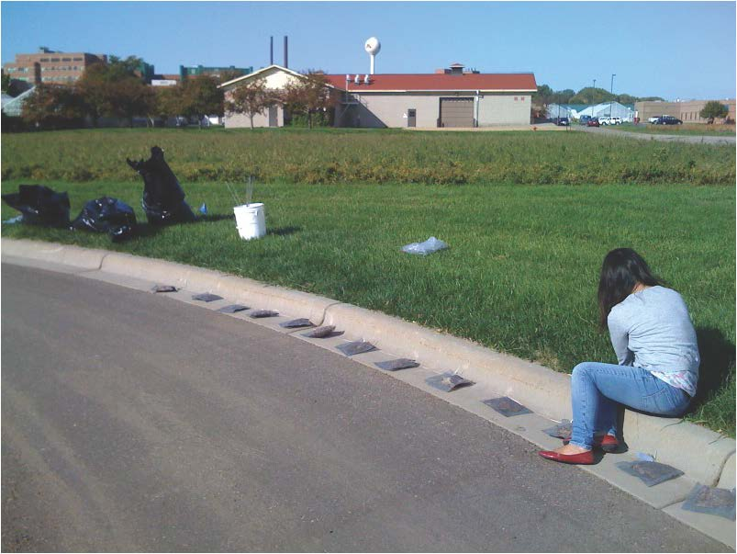

Figure . Installation of litterbags along a curb.

Sufficient bags were made to harvest three replicate bags of each species 15 times over the course of one year. We deployed bags alongside the concrete curb in a street gutter in the parking lot of the University of Minnesota Equine Center, Saint Paul, MN on Oct. 1, 2010 (Figure 23). This location was chosen because the parking lot is a large, but very little used, area so it has abundant linear meters of curb but is not prone to vandalism. Once per week, a car was driven over the bags to simulate car parking that would normally occur along curbs on city streets.

Three replicate bags were harvested every two weeks through December, 2010 and approximately monthly thereafter through October 1, 2011. No bags were harvested during February 2011 due to snow cover. Upon collection, we separated litter from bags, and dried (65°C), weighed, and ashed it for one hour (550°C) to determine ash-free dry mass remaining as a proportion of the initial ash-free dry mass. Harvested litter was analyzed for C, N, and P content, as above.

### Leaf Litter Leaching

We also determine the amount of readily leachable nitrogen and phosphorus by placing five grams of air-dried leaf litter of each species in 500 ml of deionized water in wide-mouth high-density polyethylene bottles (5 replicates/species). Samples were shaken by hand for 10 seconds and then allowed to sit at 22°C for 24 hours when they were shaken again by hand for 10 seconds. Duplicate 30 ml subsamples of leachate were taken after 30 minutes and again 24 hours, syringe-filtered through pre-ashed GF/F filters, and analyzed for dissolved organic carbon, total dissolved nitrogen, dissolved inorganic nitrogen, soluble reactive phosphorus, and total dissolved phosphorus. Dissolved organic nitrogen and phosphorus were calculated by subtracting dissolved inorganic nitrogen and soluble reactive phosphorus from total dissolved nitrogen and phosphorus, respectively.

## Results

### Decomposition

Decomposition preceded rapidly in the street, suggesting that delays in street sweeping provide an opportunity for movement of nutrients, particularly phosphorus, into the storm sewer drainage network, from decomposition and subsequent runoff of soluble material. These losses would occur in addition to any particulate nutrients that might be washed into storm drains during precipitation and snowmelt events.

For all species, there was a period of rapid decomposition in the first 1.5 months in the street, when up to 22 percent of the litter decomposed (Figure 24). By the end of one year, about 80% of the litter had decomposed for all of the species except Quercus bicolor. Litter of Quercus had lost about 60% of its initial mass by this time. The slow decomposition of Quercus bicolor compared to the other species likely related to its high litter lignin concentration (Table 7).

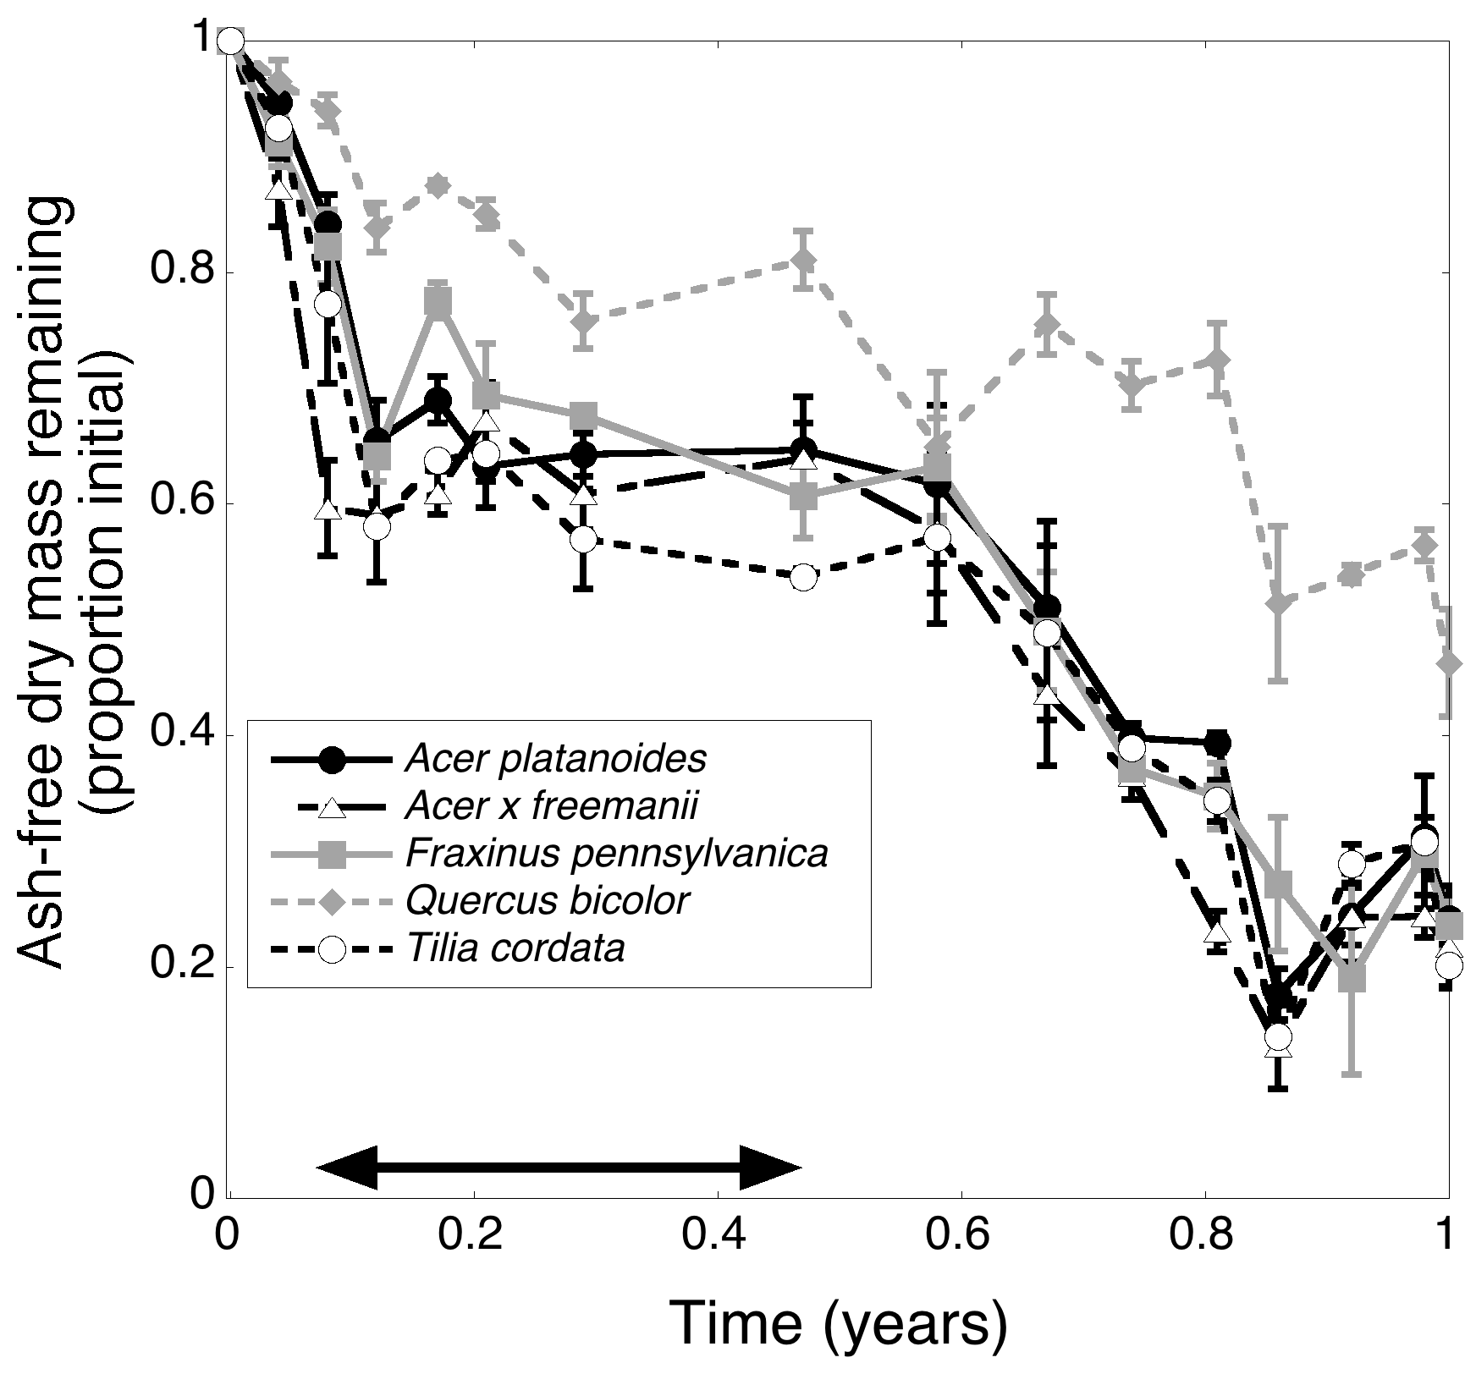

Figure . Decomposition of litter of five tree species decomposing in a street gutter, expressed as the proportion of the initial ash-free dry mass remaining over time. The arrow indicates the time during the year when precipitation fell as snow.

Table 7. Initial litter chemistry for five species studied. All parameters are expressed in percent of total mass. Values are means (standard errors).

|  |  |  |  |  |  |  |
| --- | --- | --- | --- | --- | --- | --- |
| **Species** | **N** | **P** | **cell solubles** | **hemicellulose** | **cellulose** | **lignin** |
| *Acer platanoides* | 1.22  (0.01) | 0.096  (0.004) | 26.6  (1.8) | 39.4  (1.5) | 17.8  (0.3) | 16.5  (0.2) |
| *Acer x freemanii* | 1.57  (0.02) | 0.134  (0.010) | 64.3  (0.4) | 14.0  (0.6) | 11.2  (0.1) | 10.9  (0.1) |
| *Fraxinus pennsylvanica* | 0.96  (0.13) | 0.162  (0.002) | 50.0  (1.4) | 15.5  (1.3) | 23.1  (0.1) | 11.8  (0.2) |
| *Quercus bicolor* | 1.16  (0.13) | 0.099  (0.002) | 42.6  (0.2) | 11.1  (0.2 | 22.4  (0.2) | 24.3  (0.1) |
| *Tilia cordata* | 1.39  (0.03) | 0.162  (0.010) | 38.9  (1.7) | 28.4  (1.4) | 18.7  (0.2) | 14.4  (0.6) |

If street sweeping is delayed, runoff of nutrients from decomposing litter is likely to be more substantial for phosphorus than for nitrogen. Litter retained most of its nitrogen for about 10 months, before beginning to release nitrogen (Figure 25). Phosphorus, on the other hand, was rapidly lost from litter of several species – up to 50% of the phosphorus had been lost from some species’ litter after 1.5 months, and nearly all species had lost about 50% of their initial phosphorus by the end of one year (Figure 26). This “lost” phosphorus is likely available to be washed into storm drains during rainfall and snowmelt events.

These results are consistent with the large fraction of phosphorus that was leached out of leaf litter in laboratory experiments, compared to nitrogen (Figure 27). After 0.5 hours, less than 4% of the initial nitrogen was leached, whereas 9 – 26% of the initial phosphorus was leached. After 24 hours, less than 10% of initial nitrogen was leached, whereas 28 – 88% of the initial phosphorus was leached. However, because leaf litter contains more nitrogen than phosphorus (Table 7), the absolute amounts of nitrogen and phosphorus that leached from the litter were not as different from one another (Figure 28). These results indicate that leaching losses of both nitrogen and phosphorus from litter in the street could contribute to runoff of nutrients to storm drains.

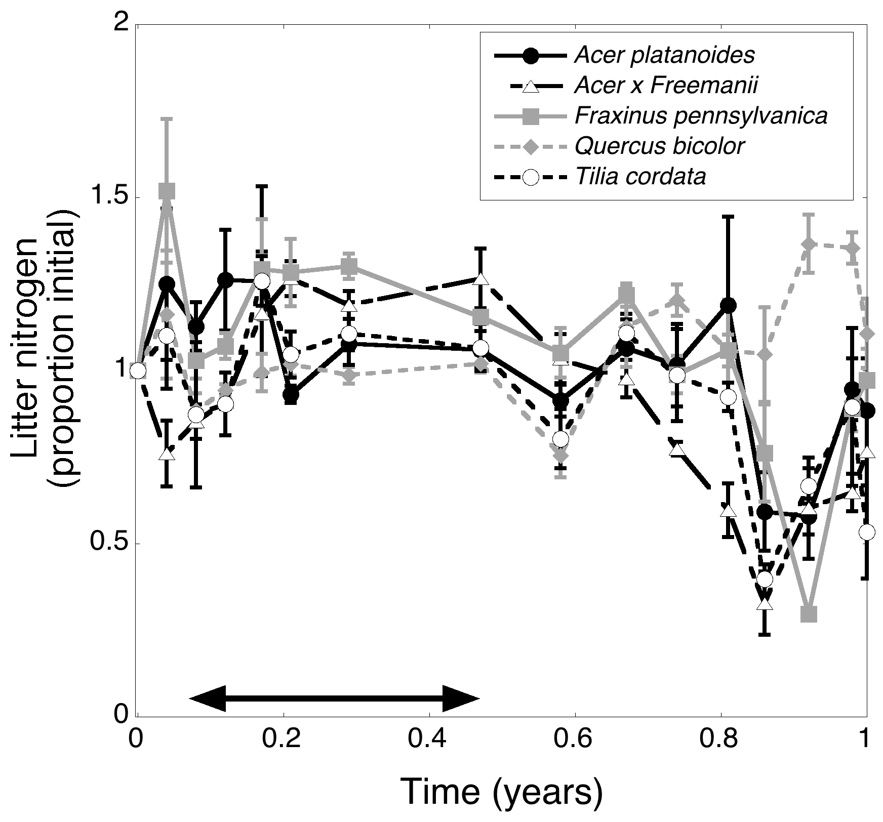

Figure . Nitrogen dynamics of litter of five tree species decomposing in a street gutter, expressed as the proportion of the initial nitrogen content present over time. The arrow indicates the time during the year when precipitation fell as snow. Nitrogen content can remain constant or even rise above 100% of the initial nitrogen content because decomposer microorganisms colonizing the litter can import nitrogen from their environment.

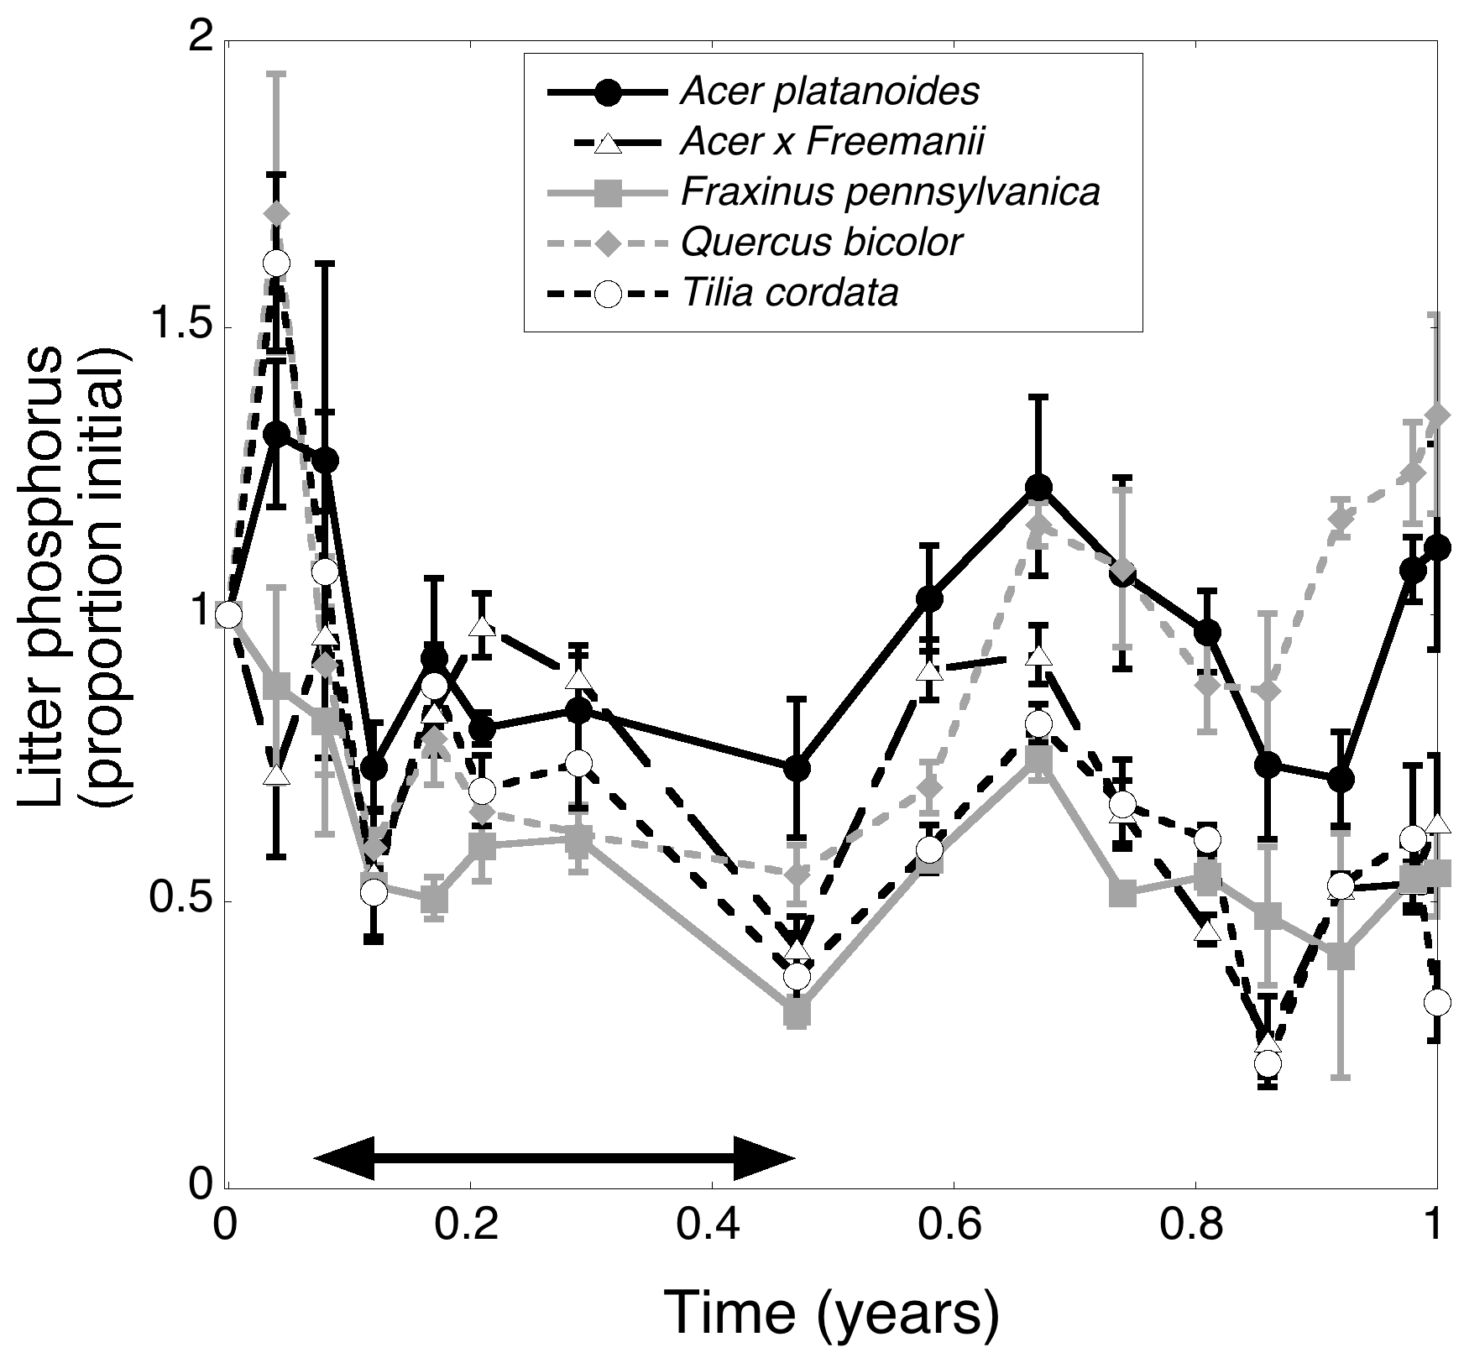

Figure . Phosphorus dynamics of litter of five tree species decomposing in a street gutter, expressed as the proportion of the initial phosphorus content present over time. The arrow indicates the time during the year when precipitation fell as snow. Phosphorus content can remain constant or even rise above 100% of the initial phosphorus content because decomposer microorganisms colonizing the litter can import phosphorus from their environment.

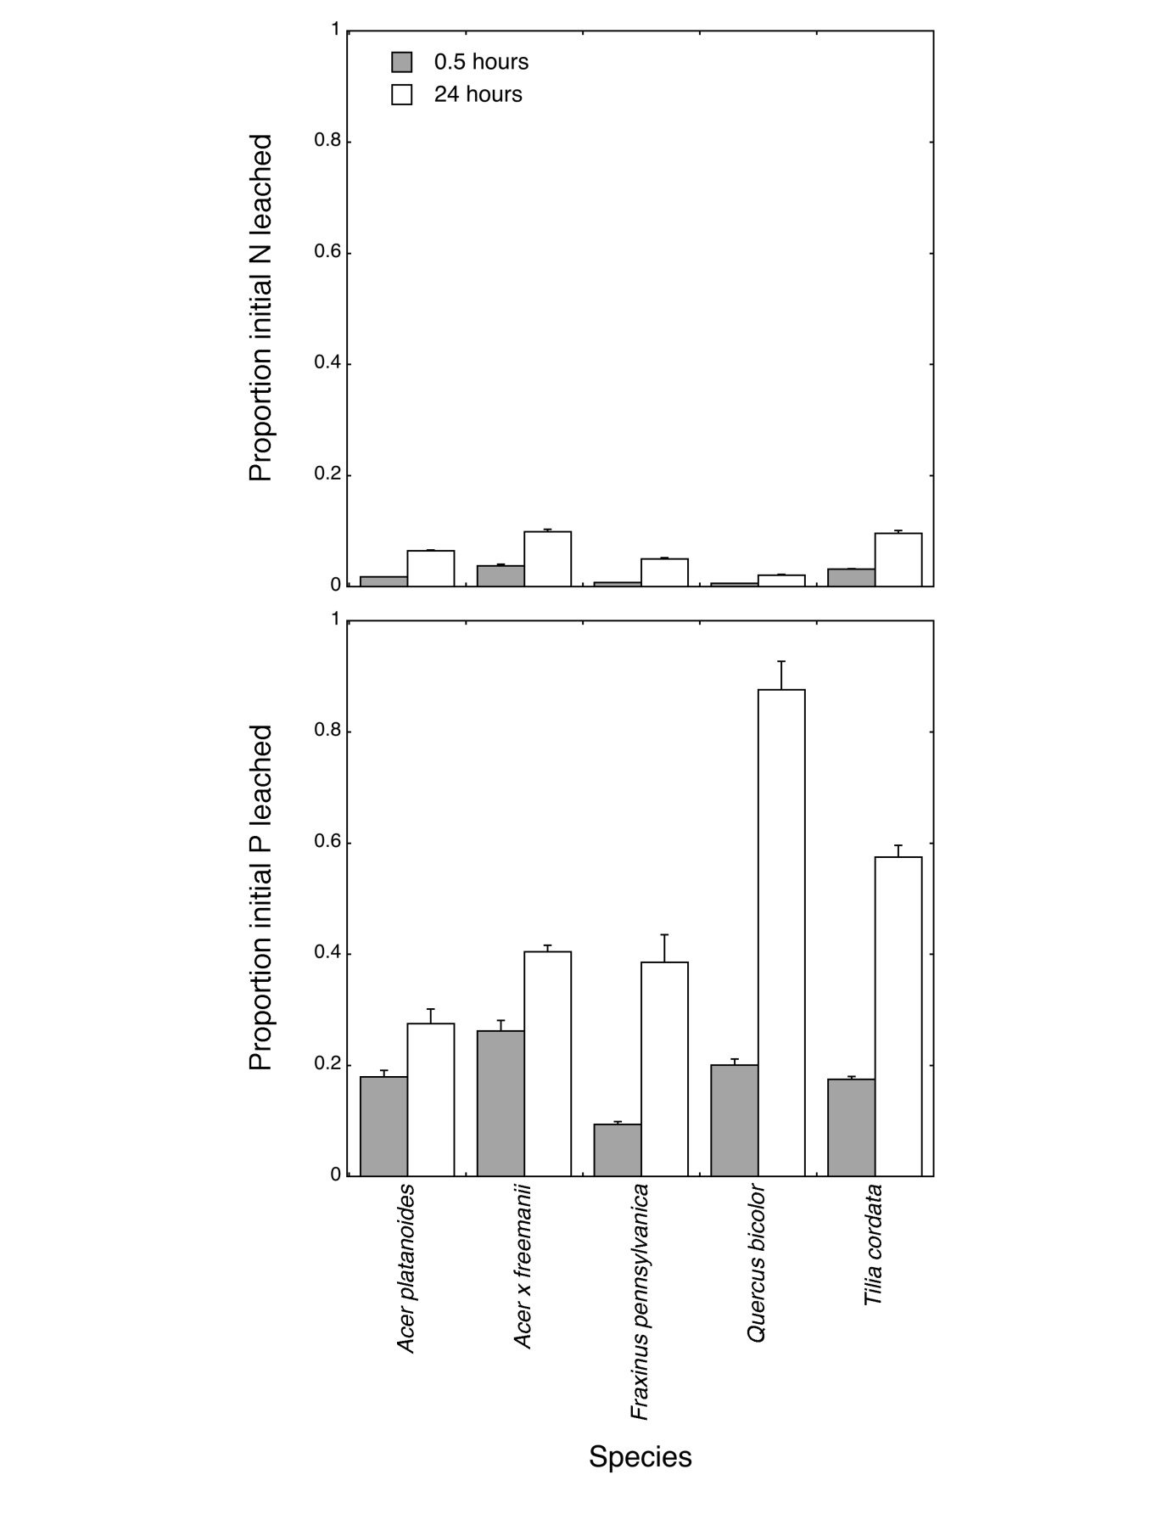

Figure . The proportions of the initial pools of nitrogen (top) and phosphorus (bottom) leached from litter over 0.5 and 24 hours in a laboratory experiment.

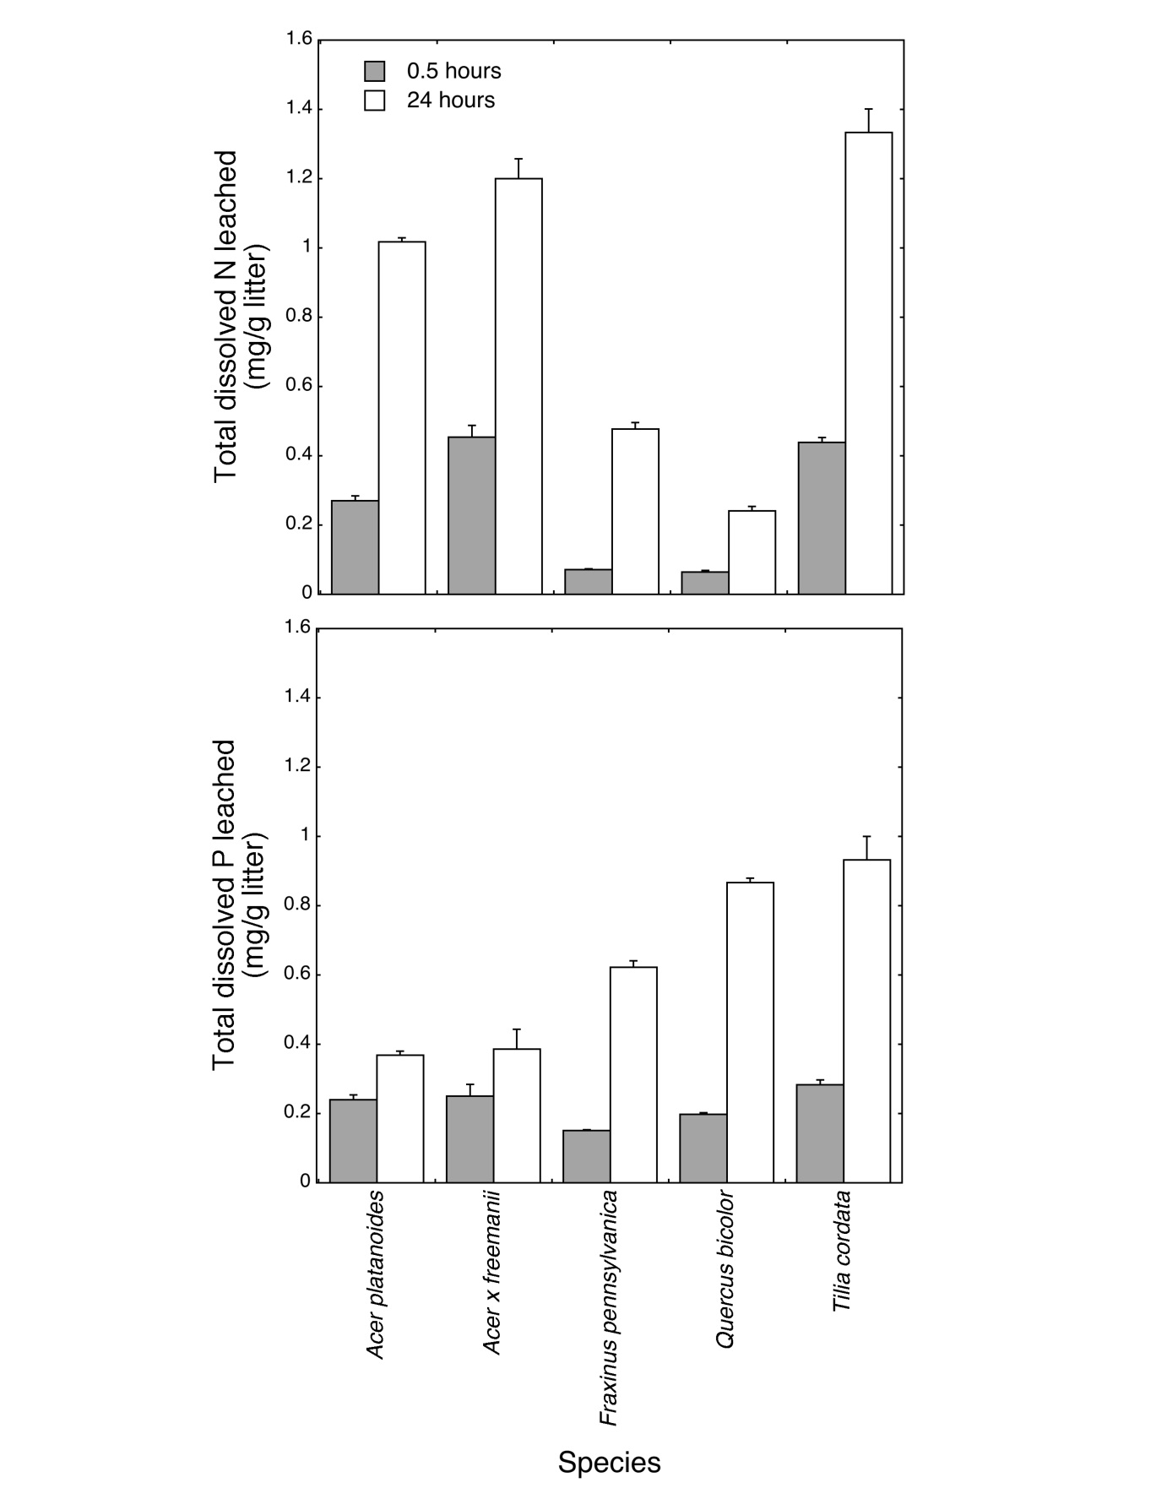

Figure . The total amount of dissolved nitrogen (top) and phosphorus (bottom) leached from litter over 0.5 and 24 hours in a laboratory experiment.

# Planning Calculator Tool for Estimating Nutrient and Solids Load Recovery through Street Sweeping

## General Model for Predicting Solids and Nutrient Loads

A main goal of the study was to develop simple statistical models that could be used to predict the solids and nutrients that could be recovered through street sweeping. These models could be used for planning sweeping programs and for estimating the potential for sweeping as a water quality BMP. Our results indicate that tree canopy cover, frequency, and the timing of sweeping all influence street sediment loads. A robust model would take all three variables into account. A practical tool would be based on inputs that can be easily supplied by the user. Through regression analysis we arrived at the simple, base model shown below. This base model can be applied to any of the load types (solids or nutrients) measured in the study, and forms the basis of the planning calculator tool.

**Log(Recovered Load)** lb/curb-miles =

β1 x (Month Factor) + β2 x (Overhead Tree Canopy) + β3 x (Sweepings per month)

This form of equation was calibrated for predictions of total solids, nitrogen, and phosphorus in our Excel-based Street Sweeping Planning Calculator Tool: Estimating Solids and Nutrient Load Recovery through Street Sweeping. To use the Calculator Tool, users specify a route, with associated over-street tree canopy cover, and then develop sweeping scenarios by altering the number of sweepings that occur during each month. This process is then repeated for other routes. The Calculator then estimates solids, nitrogen, and phosphorus removal for each route, and then for the entire swept area (all routes), with associated costs. Instructions for use of the calculator are presented in the next chapter.

Predictions were validated using a five-fold cross-validation procedure. In this procedure, the data set was randomly divided into five subsets. The model was ‘trained’ on 4/5th of the data and then used to predict recovered loads on the remaining 1/5th based on the month of the sweeping event, the over-street canopy cover for the particular route, and interval between sweeping events (sweeping frequency). This procedure was repeated with similar results in several trials. Results show that the model is very robust (Table 8).

Table . Results of five-fold cross-validation for

|  |  |  |  |
| --- | --- | --- | --- |
| **Load Component\*** | **Total Collected (lb)** | **5-fold cross validation result** | **% Error** |
| Dry Solids | 619,422 | 638,302 | 3.0% |
| Fine Solids (dry wt) | 435,199 | 443,249 | 1.8% |
| Coarse Organics (dry wt) | 95,031 | 102,875 | 8.3% |
| Fine phosphorus | 284.0 | 293.6 | 3.4% |
| Coarse phosphorus | 166 | 179 | 7.5% |
| Total Phosphorus (n=385) | 458 | 4778 | 4.4% |
| Fine Nitrogen (n=377) | 505 | 521 | 3.1% |
| Coarse Nitrogen | 1292 | 1,370 | 6.1% |
| Total Nitrogen (n=262) | 1363 | 1,913 | 5.2% |

*Sample size = 392 unless otherwise noted.

One limitation of the model is that is does not account for build-up that may occur during long intervals when sweeping is not performed (e.g., over the summer period). In such cases it is assumed that once per month sweeping frequency provides a conservative estimate of recoverable loads. Of course, predictions made using the Calculator also assume that the neighborhoods being modeled are “similar” to those in the city of Prior Lake. Some key limitations to extrapolating findings from this study to other cities were discussed in Chapter 1 and Chapter 3.

## User Guide to the Planning Calculator Tool

Planning Calculator for Estimating Nutrient Removal through Street Sweeping

Quick Reference Users’ Guide

**Overview of Planning Calculator**

The Planning Calculator for Estimating Nutrient Removal through Street Sweeping is designed to provide an estimate of the average solids and nutrient (phosphorus and nitrogen) loads that can be recovered through street sweeping based on the timing and frequency of sweeping operations and an estimate of the percent tree canopy cover over the streets to be swept. It has been calibrated to conditions in Prior Lake, MN and is recommended for use in the greater Twin Cities metropolitan Region or geographic areas with comparable climate and vegetation.

**Step 1**: Define Sweeping Routes

In order to use the spreadsheet calculator tool, the user must define sweeping routes. This information is entered on the “Routes” tab of the spreadsheet tool.

The following parameters must be defined for each route created:

1) Unique identification tag (Route ID)

2) Curb-miles to be swept (curb-mile = 1 mile along one side of a street)

3) The average **over-street** tree canopy cover for the entire route.

|  |  |  |  |  |
| --- | --- | --- | --- | --- |
| Route ID**\***  **\* Denotes Required Field** | Curb-miles**\*** | Average % Canopy Cover**\*** | Priority Rating | Unique Cost ($/curb-mile) |
| (any string of characters) | (each side of the street) | (route average) | (user defined) | (replaces default cost for special circumstances) |
| Example NW10 | 15 | 20 | 1 |  |

Sweeping routes can be designed based on any number of factors (ex. street or land use type, proximity to receiving waters, stormwater management concerns). For the purpose of the planning calculator, a route represents streets for which the timing and frequency of annual sweeping operations is (nearly) identical. For example, all street for route ‘A’ will be swept once in March and once in the October. Streets with similar characteristics for which the timing or frequency of sweeping will vary should be represented in different routes.

**Step 2**: Define Default Cost

Because the cost of sweeping operations will vary depending on sweeper type and unique overhead considerations, no default cost algorithm was built into the spreadsheet calculator tool. To include cost-estimates in planning calculations, users must supply a default cost basis in the form of the expected *cost per curb-mile of sweeping* on the “Planning” tab. Guidance on estimating the cost-per curb-mile of sweeping is provided in the spreadsheet support material. Cost estimates are not required to calculate expected recovered loads.

|  |  |  |
| --- | --- | --- |
| Green boxes are for data supplied by user | | |
|  |  |  |
| **Default Cost/curb mile** | | $ |

**Step 3**: Design Sweeping Operations for Individual Routes

Once routes have been entered on the “Routes” tab, they are available in a drop down menu on the “Planning” tab. Use the drop down menu to choose a route. The relevant route information will be loaded to the planning tab automatically.

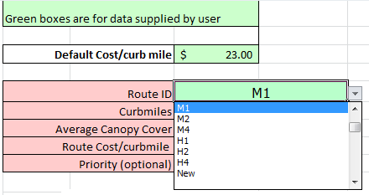

Type the number of sweeping events planned in each month for the chosen route in the frequency column of the Load Prediction table. Hit “enter” to calculate the expected recovered loads and associated costs for each sweeping event. The calculator is calibrated to sweeping frequencies between 0 times per month and once weekly. Frequencies are restricted to integer values and the maximum allowable value of ‘5’ represents the maximum number of weekly sweepings possible in a month. The calculator assumes an equal interval between sweeping operations for frequencies greater than once per month (ex. 3 times per month is calculated at a 10 day interval) and adjusts the expected load for the first sweeping event in each month to reflect sweeping intervals in the previous month.

|  |  |  |  |  |  |  |  |
| --- | --- | --- | --- | --- | --- | --- | --- |
| **Month** | **Frequency** | **Predicted (lb)** | | | | **Predicted (lb)** | |
| Wet Solids | Dry Solids | Nitrogen | Phosphorus | Cost | $ Cost/lb P |
| January |  |  |  |  |  |  |  |
| February |  |  |  |  |  |  |  |
| March | 1 | 3632 | 2931 | 1.8 | 1.6 | $ 138.00 | $ 87.45 |

**Step 4**: Create Sweeping Scenarios

When sweeping operations have been designed to satisfaction for a given route, route operations can be added to sweeping summaries to create sweeping plans. Use the “Accept Changes” button to add operations to summaries, and “Edit Routes” button to edit sweeping operations that have already been saved.

|  |  |
| --- | --- |
| New Route (ctrl+n) | “Start over” command – clears route information and computations from the calculator. |
|  | Adds the current computation to the route summaries. |
|  | Pulls information from route summaries so that routes can be edited. |

Note that the user is able to change route parameters (curb-miles, percent canopy cover) on the “Planning” tab, however, any changes made to route parameters on the “Planning” tab **will not be saved** on the “Route” tab. This means that the next time the route is called, or when the route is called for editing from sweeping summaries, the parameter values will default to those supplied on the “Route” tab.

Routes parameters may be edited at any time on the “Routes” tab; however, sweeping summaries will not automatically update to reflect these changes. To update saved sweeping operations when route parameters have changed, re-load the saved route using the “Edit Route” feature and re-save the route sweeping operations using the “Accept Changes” feature. Expected loads and cost-estimates are re- calculated when route information is loaded from sweeping summaries. The effect of changing route parameters can be seen by comparing saved values with re-calculated values when routes are called for editing. Saved values are not over-written until the user accepts edits.

**Step 5**: Export Sweeping Scenarios

When sweeping operations for all routes have been designed to satisfaction, the sweeping plan can be exported to a new workbook using the “Save/Clear” function found on any of the summary tabs. The “Save” feature will export summary information only. If additional editing work is to be complete at a later data, the workbook can simply be saved under a new file name. The workbook is not designed to re-initialize upon opening or closing, so a simple save will protect the current work. The sweeping summaries can be reset using the “Clear” feature found on any of the summary pages. Choosing this option will reset all sweeping summaries, but will not affect route parameter information. To adjust route parameters simply edit/add/delete from the “Routes” tab.

# LITERATURE CITED

Baker, L. and R. Newman. 2014. Managing the biological, economic, and social aspects of sustainable lake ecosystems. *In* Schnoor, J., *Water Quality and Sustainability*, in Volume 4, in Ahuja, S., editor-in-chief, *Comprehensive Water Quality* and Purification, Elsevier.

Bateman, M. 2005. NPDES Stormwater Strategies for Implementing TMDLs (ppt). Pennsylvania Stormwater Management Symposium, Villanova University, October 11-13.

**Ben-Dor E.,** and A. Banin, 1989, Determination of organic matter content in arid-zones soils using simple loss-on-ignition method. Communications in Soils Science and Plant Analysis, 20:1675-1695.

Berretta C., S. Raje, and J.J. Sansalone. 2011. Quantifying Nutrient Loads Associated with Urban Particulate Matter (PM), and Biogenic/Litter Recovery Through Current MS4 Source Control and Maintenance Practices. University of Florida, College of Engineering, Gainsville, Florida: Florida Stormwater Association Education Foundation Final Report #31 May 2011.

Breault R.F., K.P. Smith, and J.R. Sorenson. 2005. Residential Street-Dirt Accumulation Rates and Chemical Composition, and Removal Efficiencies by Mechanical- and Vacuum-Type Sweepers, New Bedford, Massachusetts, 2003-04. Reston, Virginia: US Geological Survey Report 2005-5184.

Burian S., S. Nix, S. Durrans, R. Pitt, C. Fan, and R. Field. 1999. Historical development of wet-weather flow management. Journal of Water Resources Planning and Management-ASCE 125:3-13.

Burton G. A. J., R. E. Pitt. 2002. Stormwater Effects Handbook. CRC Press LLC, Boca Raton, FL.

Clark S. E., C.Y.S. Sui, C. D. Roenning, D. P. Treese, R. Pitt, J. Reddy. 2007. Automatic Sampler Efficiency for Stormwater Solids. Villanova Urban Stormwater Partnership, Villanova, PA.

City of Prior Lake. 2007. 2030 Comprehensive Plan, City of Prior Lake website: <http://www.cityofpriorlake.com/planning_development_review.php>

Connecticut Department of Energy and Environmental Protection (CT DEEP). 2007. Guidelines for Municipal Management Practices for Street Sweeping and Catch Basin Cleanings. Hartord, CT.

Cowen W. F., F. G. Lee. 1973. Leaves as a source of phosphorus. Environmental Science and Technology 7 9:853-854.

Deletic A., D. Orr. 2005. Pollution buildup on road surfaces. Journal of Environmental Engineering 131:49-59.

Dorney, J.R. 1986. Leachable and total phosphorus. Water, Air and Soil Pollution 28:439-443.

Durand C., V. Ruban, A. Ambles, B. Clozel, and L. Achard. 2003. Characterisation of road sediments near Bordeaux with emphasis on phosphorus. Journal of Environmental Monitoring 5:463-467.

Easton Z. M., P. Gerard-Marchant, M. T. Walter, A. M. Petrovic, and T. S. Steenhuis. 2007. Identifying dissolved phosphorus source areas and predicting transport from an urban watershed using distributed hydrologic modeling. Water Resources Research 43:W11414.

EPA. 1983. Results of the National Urban Runoff Program, Vol. 1, Final Report. Washington, D.C.: US Environmental Protection Agency, Water Planning Division. Report PB84-185552.

Heaney J. P., R. H. Sullivan. 1971. Source control of urban water pollution. Water Pollution Control Federation 43:571-579.

Kang J., S. Debats, and M. Stenstrom. 2009. Storm-water management using street sweeping. Journal of Environmental Engineering 135:479-489.

Kim L., K. Zoh, S. Jeong, M. Kayhanian, and M. K. Stenstrom. 2006. Estimating pollutant mass accumulation on highways during dry periods RID A-3177-2008. Journal of Environmental Engineering 132:985-993.

Kuehl R., M. Marti, and J. Schilling. 2008. Resource for Implementing a Street Sweeping Best Practice. St. Paul, MN: Minnesota Department of Transportation. Report MN/RC-2008RIC06.

Land Technologies Inc. 1997. Reprocessing and Reuse of Street Waste Solids. Seattle, WA: Clean Washington Center (CWC). Report IBP-97-5.

Law N.L., K. DiBlasi, and U. Ghosh. 2008. Deriving Reliable Pollutant Removal Rates for Municipal Street Sweeping and Storm Drain Cleanout Programs in the Chesapeake Bay Basin. Center for Watershed Protection, Washington, DC.

McComb A. J., S. Qiu, R. W. Bell, and J. A. Davis. 2007. Catchment litter: a phosphorus source mobilized during seasonal rainfall RID C-4045-2009. Nutrient Cycling in Agroecosystems 77:179-186.

MPCA. 2010. Managing Street Sweepings. Solid Waste Publications. Minnesota Pollution Control Agency. St. Paul, MN: MPCA Report W-sw4-54.

Minton G., R. C. Sutherland. 2010. Street dirt: A better way of measuring BMP effectiveness. Stormwater Magazine Mar-Apr 2010.

Minton G. R., B. Lief, and R. C. Sutherland. 1998. High efficiency sweeping or clean a street, save a salmon! Stormwater Treatment Northwest Newsletter 4 4:1-6.

MWH Americas Inc. 2002. Anchorage Street Sweepings Management Plan. Anchorage, AK: Municipality of Anchorage Watershed Management Program. Report WMP CPp02001.

Pitt R. 1985. Characterizing and Controlling Urban Runoff Through Street and Sewerage Cleaning. Cincinnati OH: US EPA, Water Engineering Research Laboratory. Report EPA/600/S2-85/038.

Pitt R.E., G. Amy. 1973. Toxic Materials Analysis of Street Surface Contaminants. Washington, D.C.: US EPA, Office of Research and Development. Report EPA-R2-73-283.

Qiu S., A. McComb, and R. Bell. 2002. Phosphorus-leaching from litterfall in wetland catchments of the Swan Coastal Plain, southwestern Australia. Hydrobiologia 472:95-105.

Rochfort Q., K. Exall, J. P'ng, V. Shi, V. Stevanovic-Briatico, S. Kok, and J. Marsalek. 2009. street sweeping as a method of source control for urban stormwater pollution. Water Quality Research Journal of Canada 44:48-58.

Sansalone J., K. Spitzer. 2008. Quantifying Pollutant Loads w/ Sediment Collected by Source Control and Maintenance Practices (ppt). Florida Stormwater Association.

Sansalone J.J., R. Rooney. 2007. Assessing the Environmental Benefits of Selected Source Control and Maintenance Practices for MS4 Permits. Florida Stormwater Association.

Sartor J. D., D. R. Gaboury. 1984. Street sweeping as a water quality pollution control measure: lessons learned in the past ten years. The Science of the Total Environment 33 (1984):171-183.

Sartor J.D., G. Boyd. 1972. Water Pollution Aspects of Street Surface Contaminants. Washington, D.C.: US Environmental Protection Agency. Report EPA-R2-72-081.

Schilling, J. G. 2005. Street Sweeping-Report #2, Survey Questionnaire Results and Conclusions. Ramsey-Washington Metro Watershed District, North St. Paul.

Seattle Public Utilities (SPU). 2009. Seattle Street Sweeping Pilot Study, Monitoring Report. Seattle, WA: Seattle Public Utilities in association with Herrera Environmental Consultants.

Selbig W.R., R.T. Bannerman. 2007. Evaluation of Street Sweeping as a Stormwater-Quality-Management Tool in Three Residential Basins in Madison, WI. Madison, WI: US Geological Survey Report 2007-5156. 103 p.

Shapiro J., P. Hans-Olaf. 1974. The Minneapolis Chain of Lakes, a Study of Urban Drainage and Its Effects, 1971-73. Minneapolis, MN: Limnological Research Center, University of Minnesota. Interim Report No. 9.

Sutherland R. C. 2011. Street Sweeping 101: Using street sweepers to improve water and air quality. Stormwater Magazine, Jan-Feb 2011.

Sutherland R. C. 2008. Real World Street Cleaner Pickup Performance Testing. World Sweeper.com, Street and Municipal Sweeping: Studies.

Sutherland R. Sweep Before You Treat (ppt). 2007a. The North American Surface Water Quality Conference and Exposition, Phoenix, AZ, August 20-23.

Sutherland R. 2007b. A Proposal for a New Research Direction. The North American Surface Water Quality Conference and Exposition, Phoenix, AZ, August 20-23.

Sutherland R. 2007c. Stormwater Quality Issues and the Pollutant Reduction from Highway Cleaning Programs (ppt), Water Resources and the Highway Environment - Impacts and Solutions, July 16-17, Sanibel Island, FL.

Sutherland R. C., S. L. Jelen. 1997. Chapter 9 - Contrary to Conventional Wisdom, Street Sweeping can be an Effective BMP. Pages 1-14. *In* W. James, editor. Advances in Modeling the Management of Stormwater Impacts, Vol 5, CHI, Guelph, Canada.

Sutherland R. C., S. L. Jelen. 1996. Chapter 1: Sophisticated Stormwater Quality Modeling is Worth the Effort. Pages 179-190. *In* W. James, editor. Advances in Modeling the Management of Stormwater Impacts, Ann Arbor Press, Chelsea, MI.

Sutherland R. C., S. L. Jelen, and G. Minton. 1998. Chapter 18 - High Efficiency Sweeping as an Alternative to the Use of Wet Vaults for Stormwater Treatment. Pages 351-372 *In* W. James, editor. CHI, Guelph, Canada.

Tarr, J. 1996. Search for the Ultimate Sink: urban pollution in historical perspective University of Akron Press, Akron, OH.

Tetra Tech in association with Pacific Water Resources, Inc. 2001. Quantifying the Impact of Catch Basin Cleaning and Street Sweeping on Storm Water Quality for a Great Lakes Tributary: A Pilot Study. Upper Grand River Watershed Alliance. Report LA:P\1451001\01.

Townsend T., Y. Jang, P. Thurdekoos, M. Booth, P. Jain, and T. Tolaymat. 2002, Characterization of Street Sweepings, Stormwater Sediments, and Catch Basin Sediments in Florida for Disposal and Reuse. University of Florida: Florida Center for Solid and Hazardous Waste Management.

Vaze J., F. H. S. Chiew. 2004. Nutrient loads associated with different sediment sizes in urban stormwater and surface pollutants. Journal of Environmental Engineering 130:391-396.

Wallace T. A., G. G. Ganf, and J. D. Brookes. 2008. A comparison of phosphorus and DOC leachates from different types of leaf litter in an urban environment. Freshwater Biology :1902-1913.

Waller, D. H. 1977. Effects of urbanization on phosphorus flows in a residential system. International Symposium on the Effects of Urbanization and Industrialization on the Hydrological Regime and on Water Quality: International Association of Hydrological Sciences, France. UNESCO publication 48072. Pages 52-58.

Waschbusch R.J., W.R. Selbig, and R.T. Bannerman. 1999. Sources of phosphorus in stormwater and street dirt from two urban residential basins in Madison, Wisconsin, 1994-95. Madison, WI: U.S. Dept. of the Interior, U.S. Geological Survey Water Resources Investigation Report 99-4021.

Wilber W., Hunter, J. 1979. Distribution of metals in street sweepings, stormwater solids, and urban aquatic sediments. Journal Water Pollution Control Federation 51:2810-2822.

[X]-Absolute Value Inc. 1996. Street Dust Test Results Application Protocol, prepared for the City of Minneapolis. Stillwater, MN, December 18, 1996. Report 5, Street Dust Protocol.

Zarriello P.J., R.F. Breault, and P.K. Weiskel. 2002. Potential Effects of Structural controls and Street Sweeping on Stormwater Loads to the Lower Charles River, Massachusetts. Northborough, MA: US Department of the Interior, US Geological Survey Water Resources Investigation Report 02-4220.

# QUALITY ASSURANCE/QUALTIY CONTROL

**Sample Processing**

Field sampling – A total of 394 samples of sweeper waste were collected in Prior Lake. Vehicle operators followed a documented protocol when sampling sweeper waste. To avoid contamination of sediments, vehicle operators wore nitrile gloves and samples were stored in 1-gallon plastic freezer bags. Samples were labeled at the time of collection with the sweeping route and date of sweep and stored in a freezer at Prior Lake until collection and transported to the University of Minnesota in coolers. Due to the cost-prohibitive nature of processing, duplicate samples of sweeper waste were not taken in the field.

To insure collection of representative samples, sweeper loads were dumped before sample collection to re-mix sediments that may have stratified in the hopper. Sampling protocol required that vehicle operators visually inspect the dumped load before sample collection to estimate the portion of soil and plant debris, and to check the degree of consolidation of material from the bottom of the hopper. One handful each of sweeper material was collected from four sides of the dumped load. Samples were visually inspected after collection to insure that fractions in the sample were representative of their proportions in the dumped load. The sampling procedure was repeated if drivers determined that a sample was not representative.

Laboratory Processing – A total of 392 sweeper waste samples were processed at the University of Minnesota. Samples from two sweeping events were not processed due to ambiguous labeling. Trained laboratory staff followed documented protocols in all sweeper waste processing and standard operating procedures for laboratory safety, operation, and maintenance of equipment were followed throughout the study.

During the fractionation process, duplicate samples of about 250 mL each were taken from float separation leachate water. Leachate samples were filtered (Whatman #1, 11µm) to remove suspended particles. Quadruplicate subsamples of approximately 20 mL each were taken for TOC/TN and TP tests from each leachate sample. All samples were run along with instrument blanks (Nanopure water). Laboratory standards of KNO3 with potassium hydrogen phthalate were prepared from standard-grade stock for TOC/TN analysis. For TP analysis, K2PO4 standards were prepared from standard-grade stock. Due to high nutrient concentrations in filtered leachate, samples were diluted for analysis. Final results for all leachate analysis were reported as the average value of results for each sweeper waste sample. Results were discarded and analyses redone if the coefficient of determination (R2) for the standard curve fell below a value of 0.94.

After the fractionation and drying process, sub-samples were taken from the fine sediment fraction for chemical analysis (~15mL) and archiving (~25mL). The sub-sample taken for chemical analysis was first pulverized before further subdivision into samples for analysis of organic content, TP, and TC/TN. The coarse organic fraction was ground before sub-samples were taken for chemical analysis (~15 mL) and archiving (~25g).

Single sub-samples of ground fine (1-2g) and coarse organic (~0.5 g) sediments were ashed in clean borosilicate glass vials following the loss-on-ignition method described by Ben-Dor and Banin, (1989).

Total phosphorus was determined by colorimetric method as described in the methods section. This method was adopted for analysis of fines after more traditional methods (nitric acid digestion) proved insufficient due to high organic content in the fine fraction. Analysis was run on single sub-samples (1-4 mg) of ground, ashed fines with duplicates run every 1/10 samples, and with triplicate sub-samples for coarse organic sediments. Apple NIST 1515 Standard was used as the reference material in all TP analyses. This standard is typically used in analysis of organic matter. Due to a high organic content of the fine sediment fraction of street sweepings along with its urban, terrestrial origin, a suitable soil standard could not be identified. To insure that apple standard was an appropriate reference material for the fine, soil-like fraction, the TP content of an inorganic standard (K2PO4) was analyzed using the apple standard as a reference material. Strong agreement between the known and measured TP values provided assurance that organic matter was completely digested in the laboratory method and that the Apple NIST 1515 standard was an appropriate reference material for analysis of the fine sediment fraction.

Sub-samples of ground, fine and coarse organic material were shipped in waterproof containers via express delivery to the University of Nebraska Ecosystems Analysis Laboratory for TN/TOC analysis. Uncertainties for all laboratory methods are given in table A-1.

**Table A-1**: Uncertainty in Chemical Analysis Methods

|  |  |
| --- | --- |
| **Test** | **Error (+/-)** |
| TOC/TN – float separation leachate | ≤1% |
| TP - float separation leachate | ≤6% |
| TP - soil | Standard Curve ≤ 1%  Sample range ≤ 10% |
| TP – coarse organics | Standard Curve ≤ 1%  Triplicate average ≤ 10% |
| TN, TC - soil | Standard Curve ≤ 5%  Sample range ≤ 5% |
| TN, TC – coarse organics | Standard Curve ≤ 5%  Sample range ≤ 5% |

**Swept-Miles Audit**

As noted earlier, sweeping patterns were altered on rare occasions when weather conditions, road maintenance or other factors interrupted sweeping or when additional passes were required to complete route cleaning. A slight oversight in operations, these alterations were not recorded by the vehicle operator. To insure that the curb-miles swept (determined through GIS analysis) accounted for these exceptions, a vehicle mileage audit was performed. It was assumed that exceptions to regular sweeping patterns could be identified through driver reports where the reported miles-swept differed significantly compared to typical reported values. Using this rationale, the GPS data recorded through PreCise Mobile Resource Management software was inspected whenever the reported miles-swept varied by more than +/- 20% compared to the median mileage reported for any route. Additionally, GPS data for a random subset of 119 sweeping events for which the reported miles-swept was within tolerance was also inspected.

When GPS data indicated additional passes made by the vehicle within the given route, no adjustment was made to the curb-miles swept. When GPS data indicated that any portion of the given route had not been swept, the curb-miles swept were adjusted downward accordingly. Since sampled sweeping events were only carried out within the nine designated study routes, the curb-miles swept were never adjusted upwards. Of the 188 sweeping events inspected, 29 mileage adjustments were required. Of the 29 mileage adjustments made, 23 were identified as outside the mileage tolerance for driver-reported swept miles. The swept-miles audit results are included in Appendix J.

**Database Management**

Primary field data was collected, recorded, and maintained by the City of Prior Lake, MN. Primary laboratory data was collected, recorded, and maintained in the University of Minnesota Department of Ecology, Evolution and Behavior. Field and laboratory data were merged and maintained in the University of Minnesota Department of Bioproducts and Biosystems Engineering following University data management and security protocols.

# Appendix A



# Appendix B

Street Sweeping Study, Route Distribution, Prior Lake, MN

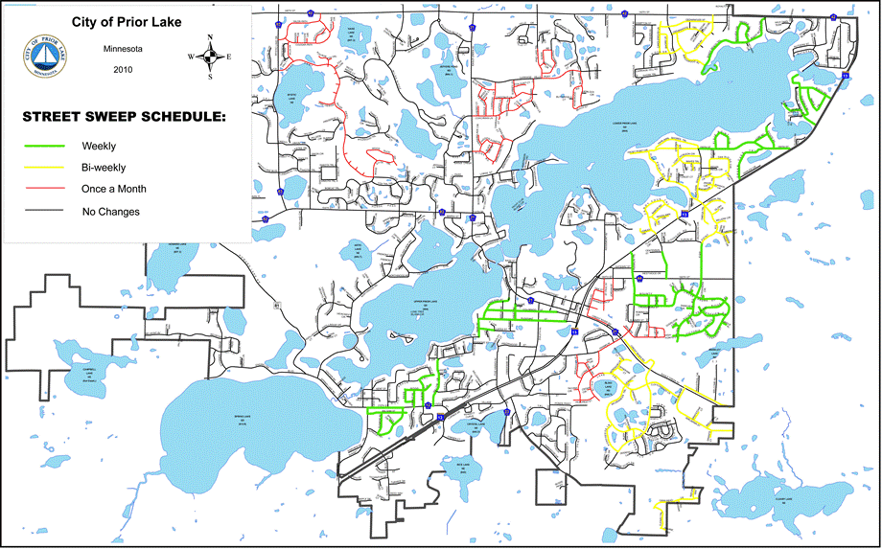

# Appendix C

Street Sweeping Study, Sweeping Route Detail

|  |  |  |  |  |  |  |  |
| --- | --- | --- | --- | --- | --- | --- | --- |
| **Study Route** | **Total Curb-Miles** | **Over-street Tree Canopy Cover (%)** | **Tree Canopy Cover within a 20 ft buffer* (%)** | **Sub-Section** | **Sub-Section Curb-miles** | **Sub-Section**  **Over-street Tree Canopy Cover (%)** | **Sub-Section**  **Canopy Cover within a 20 ft buffer* (%)** |
| H1 | 6.8 | 6.9% | 22.9% | a | 1.7 | 7.2% | 21.5% |
| b | 2.0 | 6.2% | 19.8% |
| c | 3.1 | 7.5% | 25.6% |
| H2 | 4.6 | 15.1% | 34.5% | a | 1.9 | 14.8% | 34.2% |
| b | 2.7 | 15.6% | 34.6% |
| H4 | 8.3 | 19.0% | 36.8% | a | 2.4 | 25.7% | 45.1% |
| b | 2.5 | 18.5% | 34.5% |
| c | 3.4 | 13.3% | 32.4% |
| M1 | 9.3 | 0.6% | 9.4% | a | 1.8 | 0.9% | 9.7% |
| b | 4.4 | 0.8% | 12.7% |
| c | 3.1 | 0.1% | 5.0% |
| M2 | 8.1 | 6.2% | 21.5% | a | 4.2 | 4.2% | 20.2% |
| b | 3.9 | 8.6% | 22.9% |
| M4 | 8.3 | 10.5% | 25.5% | a | 1.9 | 2.3% | 19.1% |
| b | 3.7 | 11.7% | 26.0% |
| c | 2.7 | 15.0% | 29.5% |
| L1 | 7.4 | 0.4% | 3.4% | a | 7.4 | 0.4% | 3.4% |
| L2 | 8.8 | 0.1% | 2.9% | a | 7.3 | 0.1% | 3.6% |
| b | 1.5 | 0.0% | 0.2% |
| L4 | 9.5 | 0.5% | 6.7% | a | 0.4 | 1.4% | 10.5% |
| b | 9.0 | 0.5% | 6.5% |

*Twenty foot buffer measured from curb lines.

# Appendix D

Street Sweeping Study, Driver Report

|  |  |  |  |  |  |  |  |  |  |  |  |  |  |  |
| --- | --- | --- | --- | --- | --- | --- | --- | --- | --- | --- | --- | --- | --- | --- |
|  |  | |  | |  | |  | |  | | |  | |  |
| LINE | DESCRIPTION | | DATA / CALCULATION | | LINE | | DESCRIPTION | | DATA / CALCULATION | |  | | |  |
| 1 | DAILY GAS USE | |  | |  | |  | |  | | | | | |
| A1 | OPERATOR | |  | | A2 | | SWEEP ZONE | |  | | | | | |
| B1 | EQUIPMENT | |  | | B2 | | MATERIAL VOLUME | | Sand/Dirt/ Gravel | | Leaves/ Sticks/ Grass | | | Sealcoat Chips |
| C1 | DATE | |  | |  | | (ENTER APROX. % OF LOAD) | |
| D1 | START TIME | |  | | D2 | | GROSS WEIGHT | |  | | | | | |
| E1 | END TIME | |  | | E2 | | START ODOMETER | |  | | | | | |
| F1 | TOTAL TIME | | Line E1 - Line D1 | | F2 | | END ODOMETER | |  | | | | | |
| G1 | IDLE TIME | |  | | G2 | | TOTAL DISTANCE | | Line E2 - Line D2 | | | | | |
| H1 | SWEEP TIME | | Line F1 - Line G1 | | H2 | | APX IDLE DISTANCE | |  | | | | | |
| I1 | SAMPLE ID | | Line C1 in YYMMDD, Line A2 | | I2 | | SWEEP DISTANCE | | Line F2 - Line G2 | | | | | |
|  | |  | |  | |  | |  | |  | | |  |  | |

# Appendix E

Street Sweeping Study, Fuel Mass Consumed During Sweeping Operations

Fuel mass estimation method - Since the mass of fuel consumed during sweeping could not be measured with adequate precision from a fuel gage reading, the following relationship was used to account for the mass of fuel consumed when calculating the fresh weight of swept material:

**Fresh Weight of Sweepings** **= Vehicle Gross Weight – Adjusted Vehicle Tare**

(vehicle + sweepings (vehicle + full fuel tank)

+ remaining fuel) - (estimated fuel consumed)

To determine an appropriate ‘adjusted vehicle tare’, we estimated the average fuel consumption rate using end of day re-fueling data. On 148 separate occasions, the fuel volume required to refill the vehicle fuel tank at the end of the day was recorded (to the nearest 1-gallon). An estimate of the fuel consumed per hour during sweeping operations was obtained using the recorded fuel volume and the total vehicle operation time recorded on the driver reports for the same day. The mean fuel consumption rate for the sweeping operations in the refueling data set was 4.75 +/-0.18 gal/hr (95% confidence, standard deviation +/- 1.08 gal/hr). As a conservative measure, we adopted the median fuel consumption rate, 4.85 gal/hr, for all sweeping operations. Using a fuel density of 6.943 lbs/gal for diesel fuel, the weight of fuel consumed was computed for each sweeping operation using the driver reported total time of vehicle operation:

**Fuel Consumed (lbs) = total vehicle operation time (hr) x 4.85 gal/hr x 6.943 lbs/gal**

The Tymco model 600 regenerative air street sweeper has a 50 gallon fuel tank and an empty weight, in this case, of about 17410 lb. The fresh weight of sweeping was calculated for each sweeping event using these numbers and the estimate for fuel mass consumed outlined above.

**Fresh Weight = Vehicle Scale Reading – 17760 lb - Fuel consumed**

**of Sweepings** (vehicle + sweepings (vehicle

+ remaining fuel) + full fuel tank)

Uncertainty Introduced by Fuel Mass Estimate - Assuming an uncertainty of +/- 0.25 hr for the total time reported by driver for each sweeping run and an uncertainty of +/- 0.50 gal for the refill volume of fuel, the average uncertainty in the fuel mass consumed (and therefore in the fresh weight of sweepings) for sweeping operations in the refueling data set was +/- 15.1 lb (standard deviation 2.7 lb). The vehicle scale used to obtain a fresh weight of sweepings had a precision of +/- 10lb. Therefore the typical uncertainty in the fresh weight of material collected during sweeping was about +/- 25 lb. The average fresh weight of sweeping collected per sweep during the study was 2193 lb. The total uncertainty in the fresh weight of sweeping represents an error of about +/- 1% for an average sweep.

# Appendix F

Street Sweeping Study, Study Route Sweeping Schedule

|  |  |  |  |  |  |  |  |  |
| --- | --- | --- | --- | --- | --- | --- | --- | --- |
|  | **Monday** | | **Tuesday** | | **Wednesday** | | **Thursday** | **Friday** |
| am | pm | am | pm | am | pm |  |  |
| Week 1 | H4 | M4 | L4 | H2 | L2 | H1 |  |  |
| Week 2 | H4 | M4 | L4 | M2 | M1 |  |  |  |
| Week 3 | H4 | M4 | L4 | H2 | L2 | L1 |  |  |
| Week 4 | H4 | M4 | L4 | M2 |  |  |  |  |

# Appendix G

**Sweeping Events by Month, Year, Route**

|  |  |  |
| --- | --- | --- |
| **Month** | **Year 1 Sweepings** | **Year 2 Sweepings** |
| January | (none)  **Total=0** | M4(1), H4(1)  **Total=2** |
| February | L2(1), L4(1), M4(1), H1(1), H2(1), H4(1)  **Total=6** | (none)  **Total=0** |
| March | L1(1), L4(1), M1(1), M2(2), M4(4), H4(1)  **Total=8** | L1(1), L2(2), L4(4), M1(1), M2(2), M4(4), H1(1), H2(1), H4(5)  **Total=21** |
| April | L1(1), L2(2), L4(4), M1(1), M2(2), M4(4), H1(1), H2(2), H4(4)  **Total=21** | L1(1), L2(2), L4(4), M1(1), M2(2), M4(5), H1(1), H2(1), H4(4)  **Total=21** |
| May | L1(1), L2(2), L4(4), M1(1), M2(2), M4(5), H1(1), H2(2), H4(5)  **Total=23** | L1(1), L2(3), L4(5), M1(1), M2(2), M4(4), H1(2), H2(3), H4(4)  **Total=25** |
| June | L1(1), L2(2), L4(5), M1(1), M2(2), M4(3), H1(1), H2(2), H4(4)  **Total=21** | L1(1), L2(2), L4(4), M1(1), M2(2), M4(4), H1(1), H2(2), H4(4)  **Total=21** |
| July | L1(1), L2(2), L4(4), M1(1), M2(2), M4(4), H1(1), H2(2), H4(4)  **Total=21** | L1(1), L2(2), L4(5), M2(3), M4(5), H1(1), H2(2), H4(4)  **Total=23** |
| August | L2(1), L4(4), M1(1), M2(2), M4(4), H1(1), H4(4)  **Total=17** | L1(1), L2(2), L4(5), M1(3), M2(3), M4(5), H1(1), H2(2), H4(5)  **Total=27** |
| September | L1(1), L2(2), L4(3), M1(1), M2(2), M4(3), H1(1), H2(2), H4(3)  **Total=17** | L1(1), L2(2), L4(4), M1(1), M2(2), M4(4), H1(1), H2(2), H4(4)  **Total=21** |
| October | L1(2), L2(3), L4(4), M1(1), M2(1), M4(3), H1(1), H2(2), H4(4)  **Total=21** | L1(2), L2(3), L4(4), M1(1), M2(1), M4(5), H1(1), H2(2), H4(5)  **Total=23** |
| November | L1(1), L2(2), L4(3), M1(1), M2(1), M4(5), H1(1), H2(2), H4(5)  **Total=21** | L1(2), L2(3), L4(4), M1(1), M2(1), M4(3), H1(1), H2(2), H4(4)  **Total=21** |
| December | (none)  **Total=0** | L4(2), M1(1), M2(1), M4(2), H2(1), H4(2)  **Total=8** |

# Appendix H

Street Sweeping Study, Sweeping Frequency Audit

|  |  |  |  |
| --- | --- | --- | --- |
| **Sweeping Frequency Check – all sweeping events** | | | |
| **Route** | **Average Sweeping Interval (days)** | **Median Sweeping Interval (days)** | **Standard Deviation (days)** |
| **L1** | 29.3 | 28.0 | 4.0 |
| **L2** | 15.5 | 14.0 | 4.5 |
| **L4** | 7.7 | 7.0 | 4.2 |
| **M1** | 25.8 | 28.0 | 6.5 |
| **M2** | 14.2 | 14.0 | 4.8 |
| **M4** | 8.0 | 7.0 | 3.1 |
| **H1** | 25.8 | 28.0 | 6.5 |
| **H2** | 15.9 | 14.0 | 6.6 |
| **H4** | 8.5 | 7.0 | 7.0 |

|  |  |  |  |
| --- | --- | --- | --- |
| **Sweeping Frequency Check – April through November only** | | | |
| **Route** | **Average Sweeping Interval (days)** | **Median Sweeping Interval (days)** | **Standard Deviation (days)** |
| **L1** | 29.3 | 28.0 | 4.0 |
| **L2** | 15.5 | 14.0 | 4.5 |
| **L4** | 7.1 | 7.0 | 0.8 |
| **M1** | 25.8 | 28.0 | 6.5 |
| **M2** | 14.2 | 14.0 | 4.9 |
| **M4** | 7.4 | 7.0 | 1.8 |
| **H1** | 25.8 | 28.0 | 6.5 |
| **H2** | 15.8 | 14.0 | 6.7 |
| **H4** | 7.2 | 7.0 | 1.3 |

# Appendix I

Street Sweeping Study Cost Estimate of Sweeping

The cost of sweeping operations in the study was found using the following relationships. Sources of labor and vehicle-related costs are shown in table I-1.

**Cost of Sweeping Event** = {Labor-related costs} + {Vehicle-related costs}

**Cost of Sweeping Event** = Sweep time(hr)*$60/hr + Curb-mile Swept (mi)*$5.25/mi

**Table I-1**: Source of labor-related and vehicle-related cost estimates

|  |  |
| --- | --- |
| **Labor-related Costs** | |
| **Labor** | $20-40 /hr (wages + benefits+ overhead) depending on staff level.  Combined staffing taken into account, total staff on scaled time basis (hours worked:hours sweeping) |
| **Vehicle-related Costs** | |
| **Maintenance** | $15,000/year average  Assumes replacement of all sweeping parts once over the vehicle life span plus addition engine /systems maintenance of the vehicle. |
| **Capital Depreciation** | Capital Depreciation =  (Total Cost of Vehicle + Refurbishment – Resale/Salvage)/ Vehicle Life)  Assumed 8-10 year life of sweeping components  Assumed 16-20 year life of vehicle |
| **Fuel** | 4.8 gal/hr, brush on  1.0 gal/hr, travel and idle mode |

The vehicle-related cost term of $5.25 per curb-mile swept was determined by the water resources engineer in Prior Lake using records of sweeping operations from previous years and study data. It represents the sum of vehicle-related costs given in Table I-1 scaled to “brush-on” curb-miles only. Given that vehicle mileage depends on mode of operation, vehicle-related costs would vary somewhat depending on the proportion of miles typically driven in travel and sweep modes of operation. The average cost of sweeping for different cost basis scenarios is given in table I-2. Since travel miles (brush off) will vary for different sweeping operations, estimate III may be the best general estimate of sweeping cost.

**Table I-2**: Estimates of cost per curb-mile of sweeping operations

|  |  |  |
| --- | --- | --- |
| **Cost Basis** | **Average $/mi** | **St. Dev.** |
| I. “Brush on” time and swept-miles only | $22 | +/- $6 |
| II. Total time (includes travel, weighing and dump time) and total miles of sweeping operation  (includes travel miles to and from route and scale) | $18 | +/-$3 |
| III. Total time of operation and swept miles only. | **$23** | **+/- $7** |

# Appendix J

Street Sweeping Study, Miles Swept Audit

Table . Swept Miles Audit Results

| **Reported Miles Swept ≤ 80% Median Miles Swept (per route)**  **Audit of GPS data vs. GIS route mile analysis** | | | | |
| --- | --- | --- | --- | --- |
| Route | Date | Difference, Reported vs. Median (%) | Audit Findings | Correction (mi) |
| L1 | 5/18/11 | -50 | No irregularities | - |
| L1 | 8/17/11 | -38 | No irregularities | - |
| L1 | 6/13/12 | -25 | No irregularities | - |
| L2 | 9/1/10 | -64 | No irregularities | - |
| L2 | 10/7/10 | -36 | No irregularities | - |
| L2 | 5/4/11 | -36 | No irregularities | - |
| L4 | 10/18/10 | -55 | GPS data not retrievable | - |
| L4 | 9/14/10 | -45 | No irregularities | - |
| L4 | 11/2/10 | -36 | No irregularities | - |
| L4 | 8/9/11 | -27 | No irregularities | - |
| L4 | 12/20/11 | -27 | No irregularities | - |
| M1 | 11/10/10 | -31 | Portions of middle section not swept. | -1.5 |
| M2 | 7/19/11 | -33 | Portions of south section not swept | -1.2 |
| M2 | 8/2/11 | -33 | Portion of north section note swept | -3.0 |
| M2 | 6/20/12 | -33 | South section not swept | -3.8 |
| M2 | 7/3/12 | -22 | No irregularities | - |
| M2 | 7/31/12 | -22 | Portion of north section note swept. | -1.2 |
| M4 | 11/28/11 | -44 | Middle and south sections not swept; portions of north section not swept | -4.8 |
| M4 | 3/19/12 | -44 | Middle section not swept, portions of north and south section not swept | -4.5 |
| M4 | 10/10/11 | -33 | South segment not swept | -1.8 |
| M4 | 10/19/10 | -22 | No irregularities | - |
| M4 | 2/16/11 | -22 | No irregularities | - |
| M4 | 3/26/12 | -22 | South segment not swept; portions of middle section not swept. | 3.6 |
| H1 | 8/26/10 | -25 | Portions of northwest section not swept | -1.7 |
| H1 | 3/7/12 | -25 | Portions of northwest section not swept | -1.0 |
| H2 | 11/17/11 | -29 | No irregularities | - |
| H2 | 6/12/12 | -29 | No irregularities | - |
| H4 | 8/8/11 | -67 | Portions of middle and south sections not swept | -0.8 |
| H4 | 10/19/10 | -44 | South section not swept | -3.3 |
| H4 | 10/10/11 | -44 | South section not swept, portions of middle section not swept | -3.5 |
| H4 | 12/12/11 | -44 | No irregularities | - |
| H4 | 10/4/10 | -33 | Portions of middle section not swept | -2.8 |
| H4 | 10/11/10 | -33 | Portions of middle section not swept | -2.0 |
| H4 | 11/1/10 | -33 | Portions of middle section not swept | -2.1 |
| H4 | 11/22/10 | -22 | No irregularities | - |
| H4 | 5/16/11 | -22 | No irregularities | - |
| H4 | 8/22/11 | -22 | No irregularities | - |
| H4 | 10/3/11 | -22 | No irregularities | - |
| H4 | 4/2/12 | -22 | No irregularities | - |
| H4 | 4/30/12 | -22 | No irregularities | - |

|  |  |  |  |  |
| --- | --- | --- | --- | --- |
| **Reported Miles Swept ≥ 80% Median Miles Swept (per route)**  **Audit of GPS data vs. GIS route mile analysis** | | | | |
| Route | Date | Difference, Reported vs. Median (%) | Audit Findings | Correction (mi) |
| L1 | 3/21/12 | +25 | 3rd, 4th pass apparent in some portions of route. | - |
| L1 | 10/20/10 | +33 | No irregularities | - |
| L2 | 6/13/12 | +55 | No irregularities | - |
| M2 | 3/13/12 | +22 | Portions of north and south sections not swept | -1.2 |
| M2 | 12/13/11 | +100 | No irregularities | - |
| M4 | 10/4/10 | +22 | No irregularities | - |
| M4 | 10/11/10 | +22 | No irregularities | - |
| M4 | 6/6/11 | +22 | No irregularities | - |
| M4 | 8/8/11 | +22 | No irregularities | - |
| M4 | 1/9/12 | +44 | No irregularities | - |
| M4 | 7/16/12 | +344 | No irregularities | - |
| H1 | 10/7/10 | +25 | No irregularities |  |
| H1 | 9/1/10 | +38 | Northwest section not swept | -2.0 |
| H1 | 5/4/11 | +50 | No irregularities | - |
| H1 | 9/21/11 | +50 | No irregularities | - |
| H1 | 8/25/11 | +63 | No irregularities | - |
| H2 | 3/20/12 | +29 | No irregularities | - |
| H2 | 9/14/10 | +43 | No irregularities | - |
| H2 | 10/18/10 | +43 | GPS data not retrievable | - |
| H2 | 11/2/10 | +43 | No irregularities | - |
| H2 | 2/17/11 | +114 | No irregularities | - |
| H2 | 12/20/11 | +143 | No irregularities | - |
| H4 | 10/25/10 | +22 | North section not swept | -2.5 |
| H4 | 9/12/11 | +22 | No irregularities | - |
| H4 | 9/13/10 | +33 | No irregularities | - |
| H4 | 3/12/12 | +33 | No irregularities | - |
| H4 | 3/5/12 | +89 | No irregularities | - |
| H4 | 7/16/12 | +100 | No irregularities | - |

| **Reported Miles Swept within +/- 20% of Route Median Miles Swept (per route)**  **Random audit of GPS data vs. GIS route mile analysis** | | | |
| --- | --- | --- | --- |
| **Route** | **Dates** | **Audit Findings** | **Corrections** |
| L1 | 11/18/10 9/9/11  3/11/11 10/5/11  6/15/11 4/18/12 | (none) | (none) |
| L2 | 8/25/10 8/17/11  9/16/10 9/9/11  10/20/10 9/21/11  11/18/10 10/19/11b  4/20/11 5/2/12  5/18/11a 5/16/12  7/13/11 5/31/12 | a) Southeast section not swept  b) Fishpoint Road not swept on main segment | a) -4.3 mi  b) -1.5 mi |
| L4 | 8/17/10 7/19/11  8/24/10 9/20/11  9/21/10 10/25/11  10/12/10 11/17/11  10/26/10 11/29/11  4/19/11 3/6/12  4/26/11 4/10/12  6/1/11 5/15/12  6/14/11 6/5/12  6/21/11 6/20/12 | (none) | (none) |
| M1 | 8/26/10 9/28/11  9/9/10 10/26/11  3/11/11c 11/23/11  5/11/11 3/14/12d  8/10/11 6/6/12  8/31/11 | c) Portions of north segment not swept  d) Portions of north segment not swept | c) -0.7 mi  d) -0.3 mi |
| M2 | 8/17/10e 5/24/11  9/8/10 6/21/11  9/21/10 10/25/11  3/14/11 11/8/11  4/12/11 5/22/12  5/10/11 6/5/12 | e) South segment not swept | e) -3.8 mi |
| M4 | 8/9/10 7/18/11  8/30/10 8/1/11  9/7/10 8/15/11  9/13/10 9/19/11  10/25/10f 10/24/11  11/1/10 11/7/11  11/22/10 4/2/12  4/18/11 4/9/12  5/12/11 5/21/12  5/23/11 6/18/12  5/31/11 7/9/12  6/13/11 7/23/12 | f) Middle and south segments not swept | f) -4.6 mi |
| H1 | 2/18/11 4/4/12  4/6/11 6/27/12  11/18/11 7/25/12 | (none) | (none) |
| H2 | 4/5/11 10/4/11  5/3/11 11/29/11g  6/29/11 6/26/12  7/12/11 7/24/12  9/7/11 | g) Portions of north section not swept | g) -2.0 mi |
| H4 | 8/9/10 7/25/11  8/31/10 10/17/11  11/8/10 10/31/11  3/29/11 1/9/12  4/4/11 4/23/12  5/2/11 5/7/12  5/9/11 6/4/12  7/5/11 6/25/12  7/11/11 | (none) | (none) |